Competitor Analysis

# **ECW**

## **Patient Registration:**

The top banner features a patient lookup option, which includes a dropdown menu with two distinct workflows.

1. Patient Look up  
2. Quick Registration

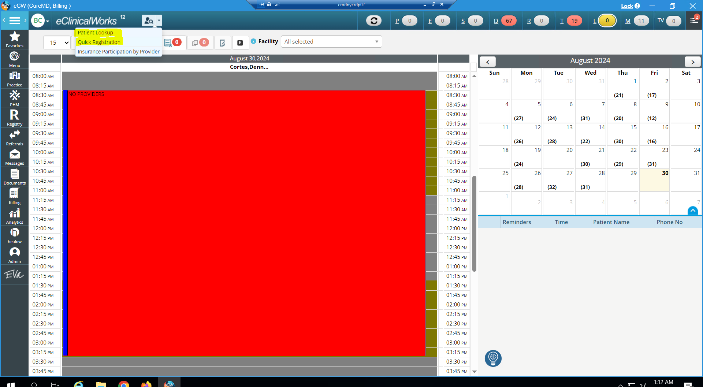

Figure 1- Landing Page

The "Patient Lookup" screen has search fields for patients by name and date of birth (DOB) under "Primary Search" and "Secondary Search," respectively. Additional filters include "Status" and "Facility."

There are buttons for

1. Quick registration + appointment,
2. New Patient and
3. Quick registration

The searched results are displayed in a table with headers: patient alerts, last name, first name, middle name, DOB, sex, account number (MRN), phone, guarantor name, and last appointment.

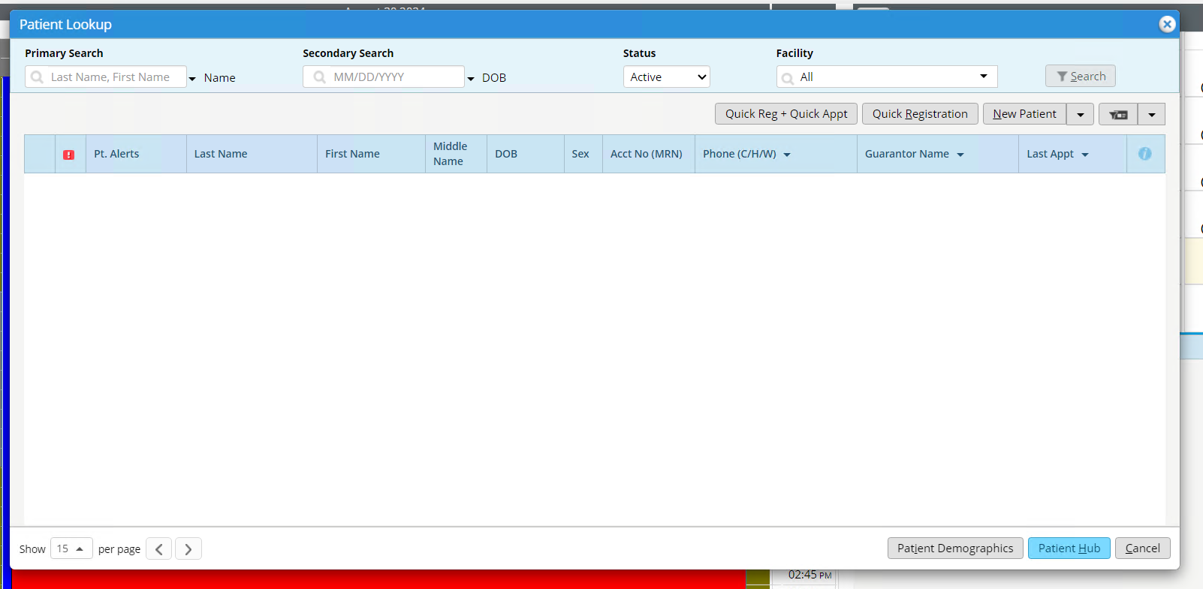

Figure 2 - Patient Lookup

The 3 options to register a patient are shown below:

1. Patient look up >> Quick Reg + Quick Appt

"New Appointment - Walk-In" form that is divided into two sections: "Patient Info" and "Visit Info."  
In the "Patient Info" section, there are fields for entering the patient's last name, middle name, first name, date of birth (DOB), sex, and cell phone number, with the option to enable text messaging.

In the "Visit Info" section, there are fields to set the appointment date/time, select the facility, appointment provider, resource, visit type, visit status, and reason for visit.

At the bottom of the form, there are three action buttons: "Save," "Save and Send Check-In SMS," and "Cancel."

In CureMD, users cannot complete quick registration and schedule an appointment from a single screen by inputting only the required fields.  
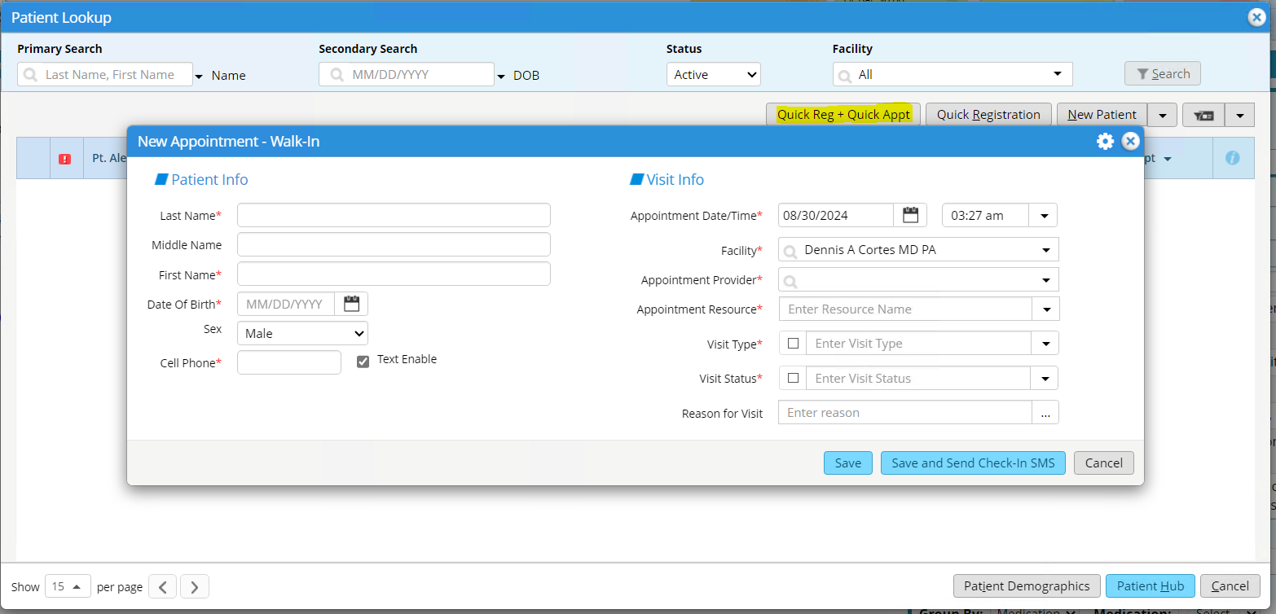

Figure 3- On clicking Quick Reg + Quick Appt

2. Patient look up >> Quick Registration   
The "Quick Registration" form has fields: patient's last name, first name, email, and a dropdown for "CC". There is also a radio button option for "In Scope" or "Out of Scope" and a dropdown menu to select the reason.

On the other side, there are fields for middle initial (MI), sex, date of birth (DOB), phone number, and options for "Patient Seen" (Yes/No). Additionally, there is a "Sent To" dropdown for further categorization.

At the bottom, there are two buttons: "Save" and "Cancel."

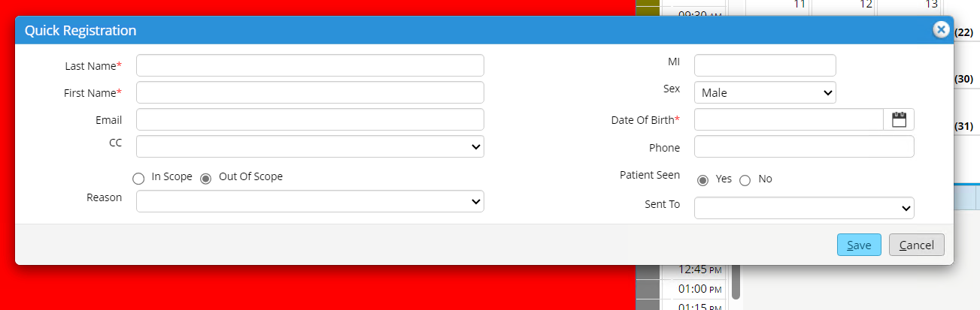

Figure 4- On clicking Quick Registration

3. Patient look up >> New Patient

The "New Patient Information" form divided into multiple sections for collecting detailed patient information:

* Patient Details: includes fields for the account number, name (first, last, suffix, previous, and preferred), address, city, state, ZIP code, phone numbers (home, cell, work), email, and other basic details.
* Date of Birth, Age, Sex, and SSN: contains fields for the patient's date of birth, age, sex, and Social Security Number (SSN), with additional options for SOGI (Sexual Orientation and Gender Identity).
* Responsible Party and Emergency Contacts: Fields for adding the responsible party's information, and emergency contacts, with relation details.
* Insurance Information: A section to manage insurance details with options to add pharmacies, contacts, attorneys, and other case management data.
* Additional Information: Fields for selecting the primary care provider (PCP), referring provider, marital status, language, race, ethnicity, Rx history consent, release of information, and signature date. There are also fields for employment, student status, default facility, and notes.

Action buttons include "Save," "Cancel," and options for adding more information like alerts, insurance, and miscellaneous info.

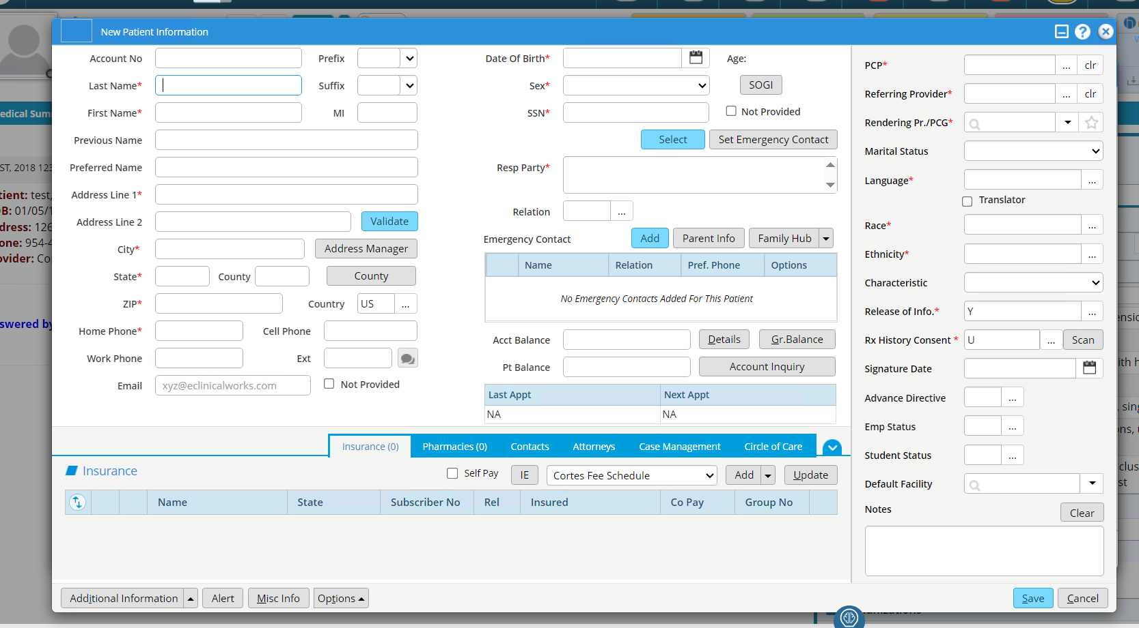

Figure 5- On clicking New Patient

Apart from patient lookup, the patient can be registered through the following workflow as well:

Practice >> Appointment Search >> New Patient

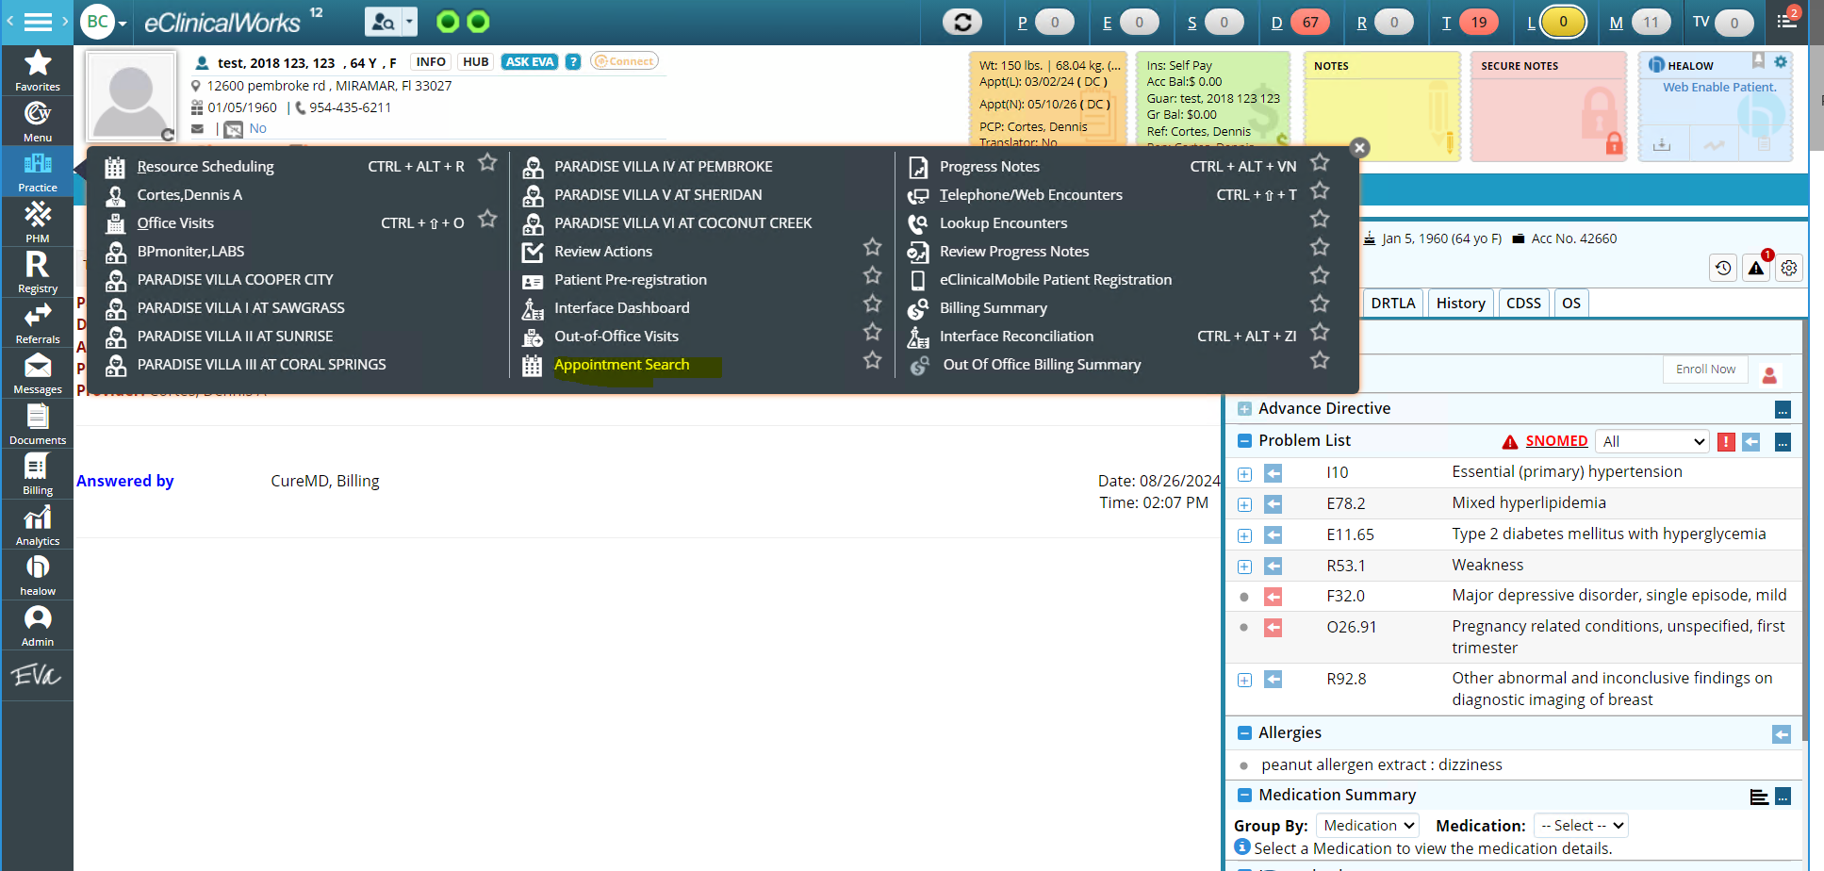

Figure 6- Appointment Search

When the user clicks on "Appointment Search," user is directed to the “Centralized Appointment Booking” page. On this page, there is a button labeled "New Patient", as shown below:

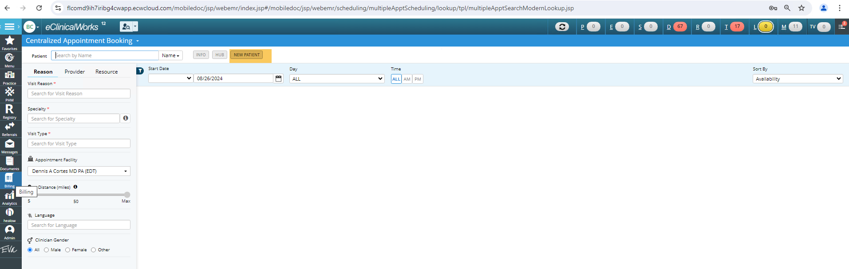

Figure 7- Centralized Appointment Booking

On-clicking

## **Scheduling**

(Repeated flow)

Patient look up >> Quick Reg + Quick Apt. >> Visit Info

In CureMD, there is no single view to add patient along with Scheduling through a single view/screen.

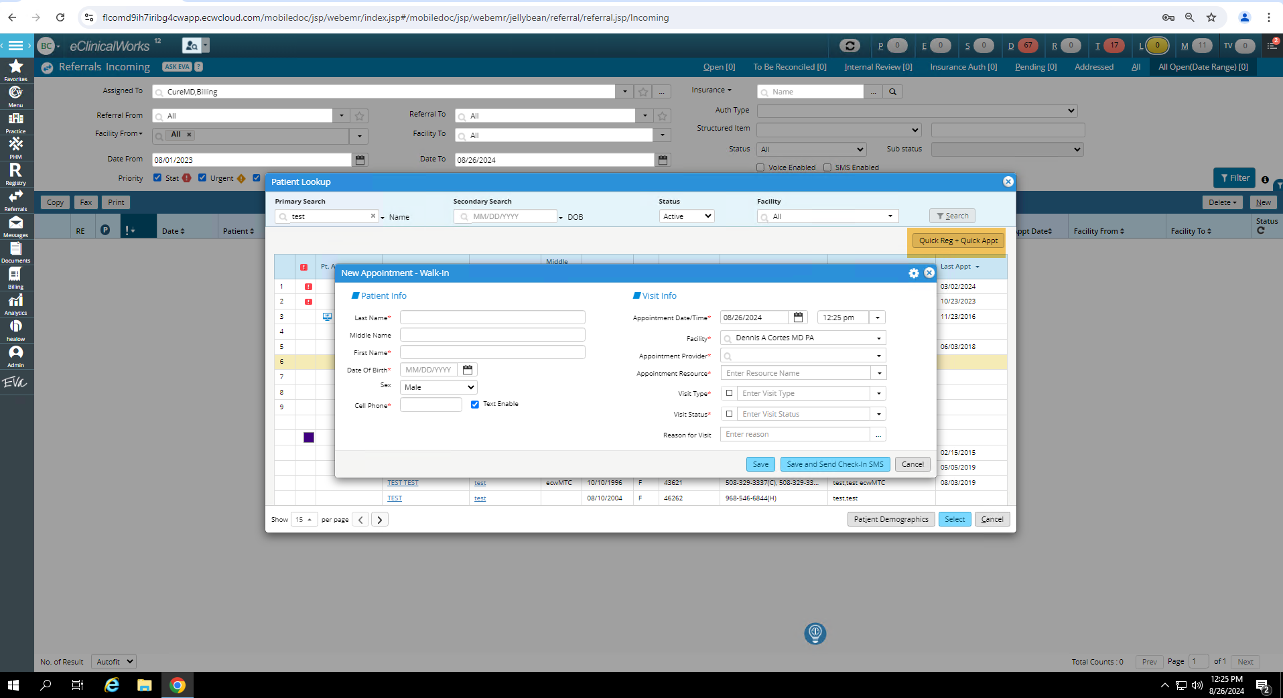

Another workflow to schedule a patient is through:   
Registry >> Lookup encounter >> New Appt

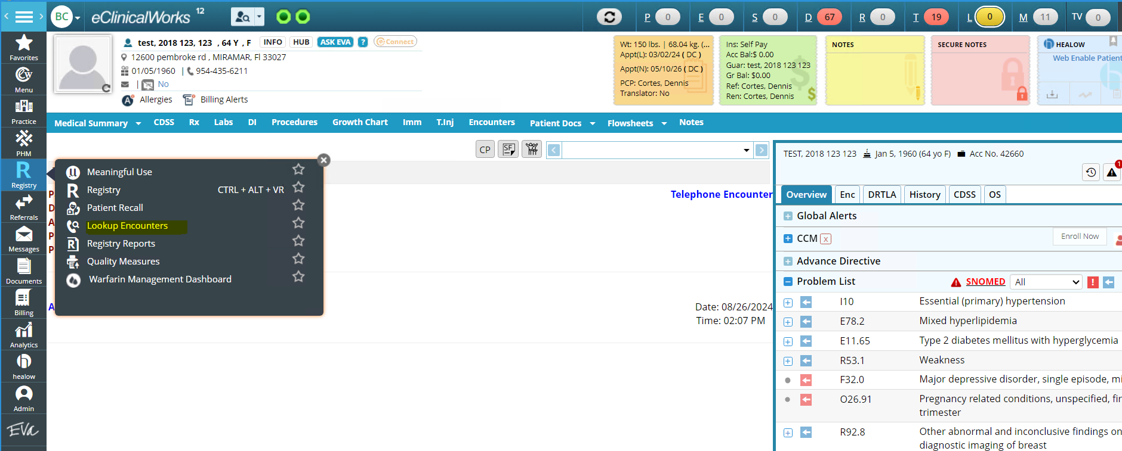

On the “Lookup Encounters” page, there is “New Appt” button. On-clicking the button, an Appointment form is displayed (Figure below).

In the billing section, fields are for managing the financial aspects of the patient visit:

* Open Cases: Allows the selection of an open billing case linked to the patient's account, indicating previous billing actions.
* Referral: Indicates if the visit requires a referral, with the option to select "Yes" or "No".
* Billing Notes: Additional billing-related notes about the patient's visit or charges.
* Claim Data Button: Claim-specific information for the visit.
* Co-Pay/Claim Changes: An option to adjust the co-pay or claim for this particular visit. The user can either maintain the original co-pay or change it for this visit only.

In CureMD, there is no co-pay or non-billable check-box on the Appointment. They do not treat check-in explicitly.

Option to enter co-pay is during check-in.

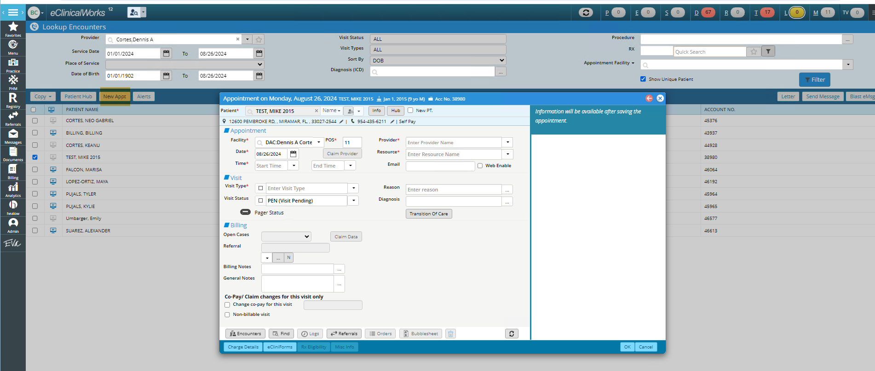

Figure 8- Appointment

There is another workflow on the “Lookup Encounters” page to book “New Appt”.

Registry > Lookup encounter > Patient Hub > New Appointment

In CureMD, there is no workflow for “New Appointment” in patient demographics. We do not display the last appointment and the next appointment in patient demographics.

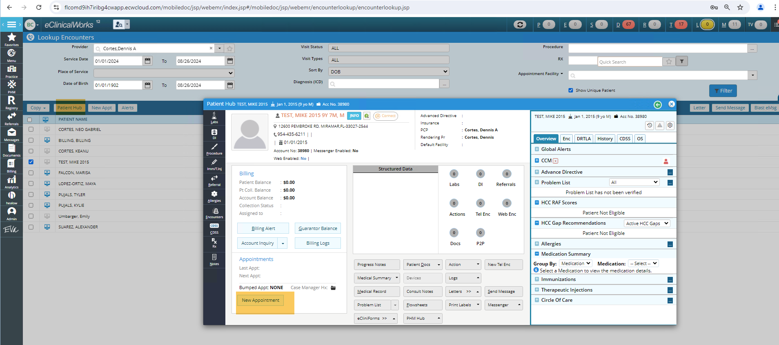

Figure 9- Patient Hub>> New Appointment

## **Progress Notes**

In 10g, provider note is created. eCW calls it progress note.

The Progress Note can be accessed through Encounter. There are 2 Encounter types:

1. Telephone/ Web Encounter
2. Office Visit

**Workflow:**

Jelly Bean Tasks >> Tele Encounter >> Search >> Progress Notes

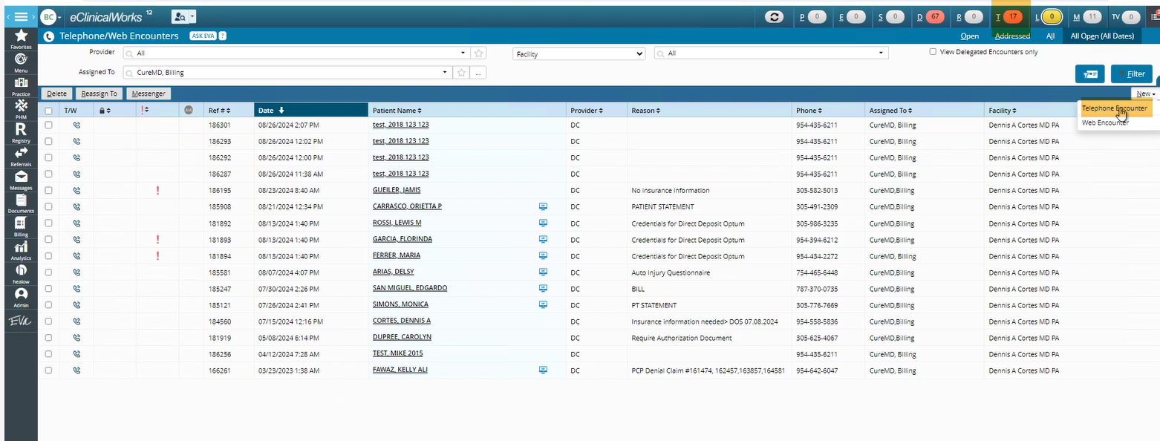

From the listing page “Telephone/Web Encounters”, click on any row to navigate to the respective encounter page.

On this page, there is a button “Progress Note” at the bottom. This navigates to the Progress Note.

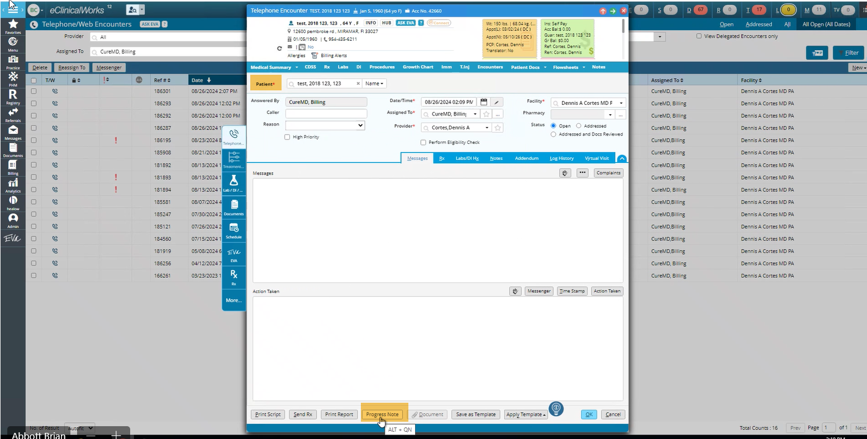

Similarly, the following workflow navigates the user to the “Progress Note” of an office visit.

Practice >> Office Visits >> Select patient>> Progress notes

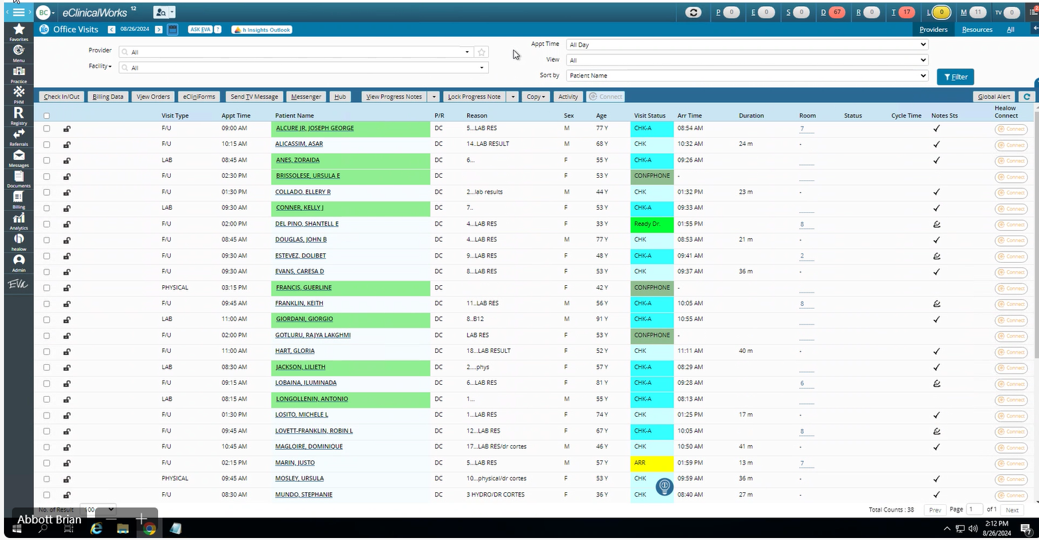

Following is the “Progress Note”.

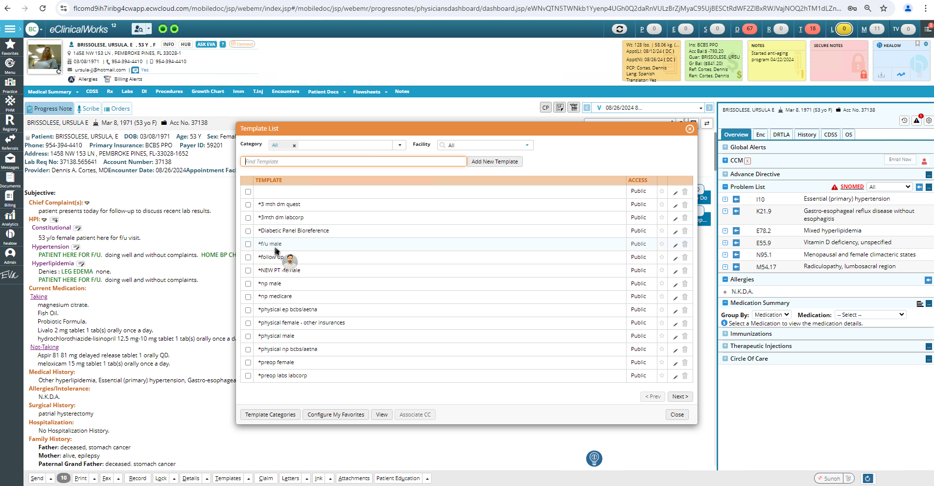

Figure 10- Progress Note

## **Encounters**

Following is a workflow to create “Tel Encounter”

Billing > Patient > New Tel Encounter

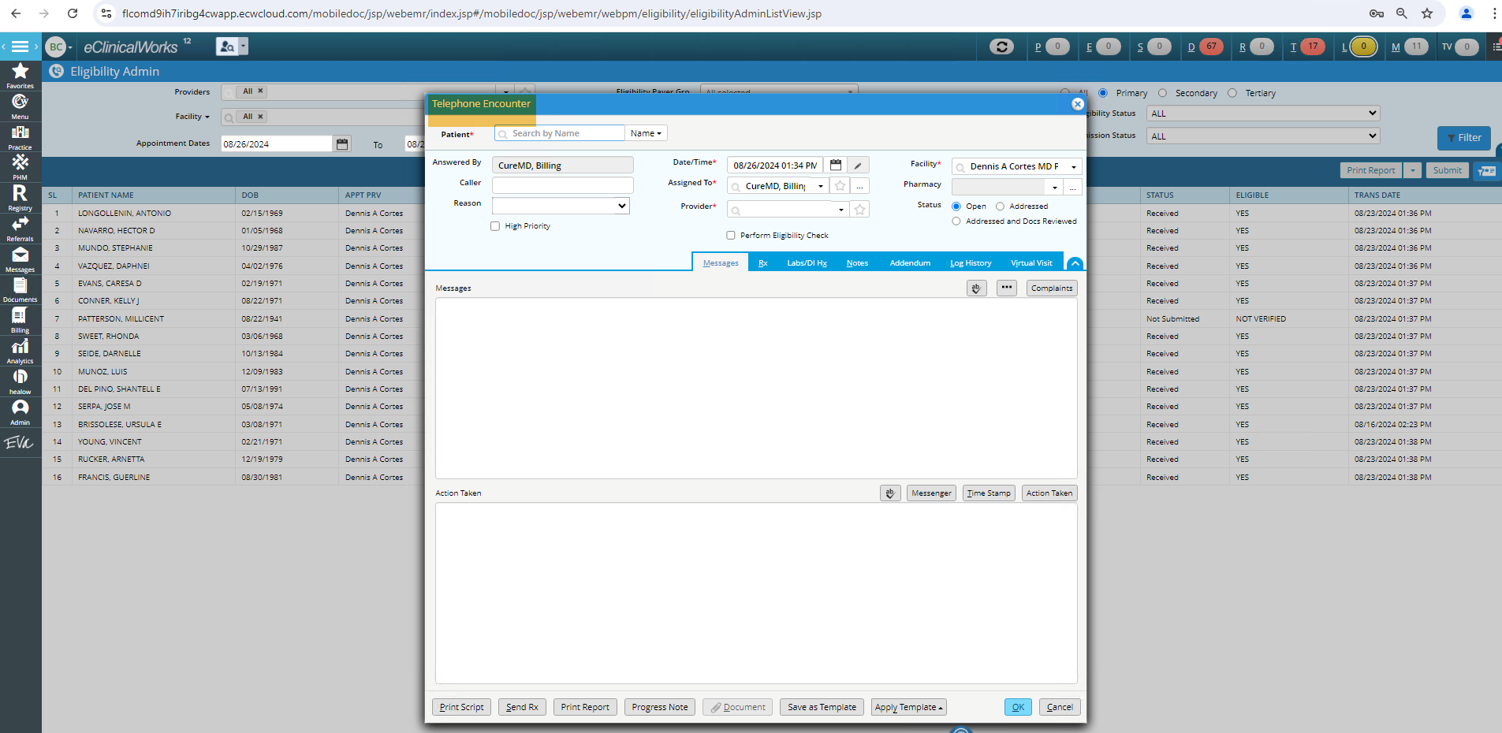

Figure 11- Telephone Encounter

And, following is a workflow to create “Web Encounter”

Billing > Patient > New Web Encounter

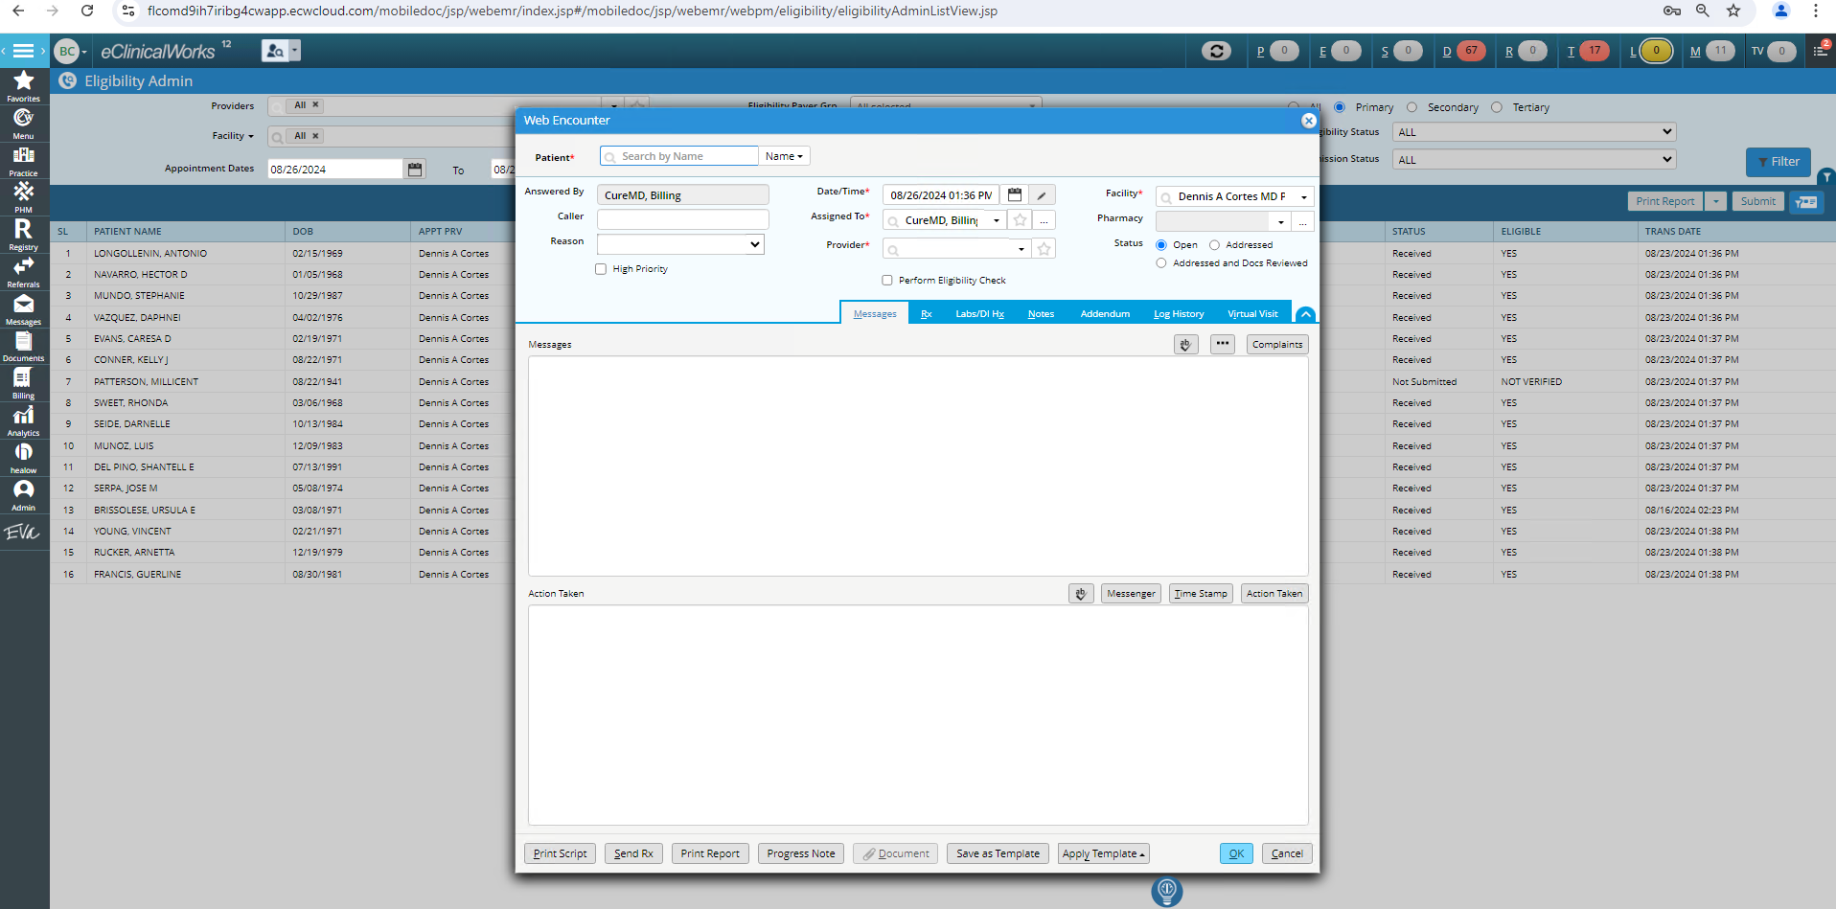

Figure 12- Web Encounter

~~In eCW, an encounter is Bill that consists of Medical codes.~~

Practice > Office Visit > View encounter from progress notes to along with scheduling new future appt.

In Curemd, the Encounter is the eSuperBill.

There is no option to create a follow-up appointment from the provider note (progress note) or on an encounter (Charge)

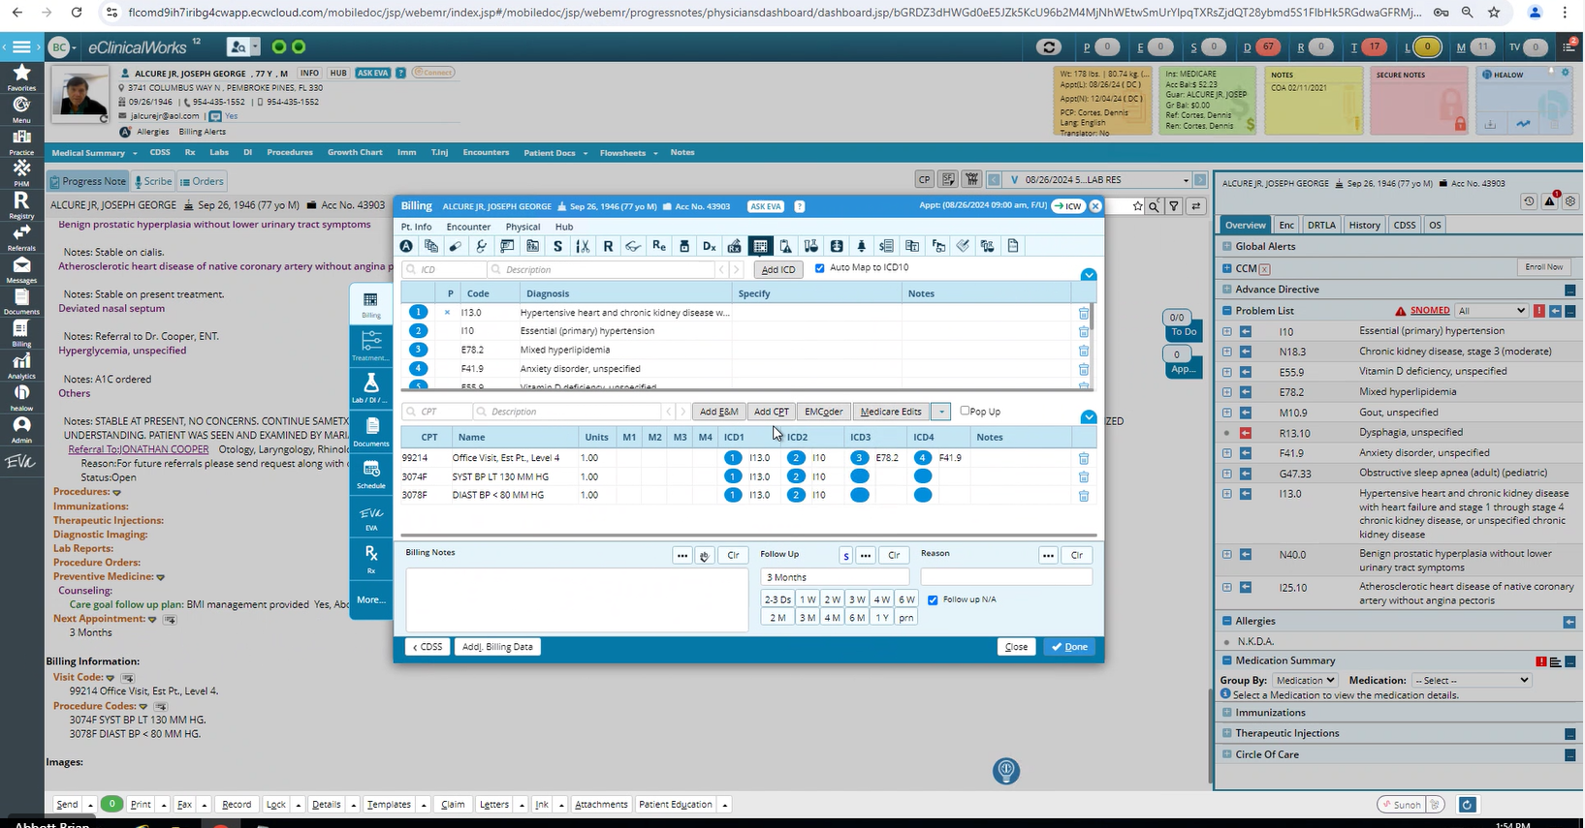

## **Claim Creation**

To Create New Claim, following are the workflows:  
  
1. Billing > Claims > Claims Status= Encounter without claims > Create New claim

2. Billing >> Claim >> Create Claim

3. Practice > Office Visit> progress note> Claim New Claim

4. Menu >> Billing > Create Claim

In eClinicalWorks (eCW), claims are organized based on their claim status. To view all encounters that do not have associated claims, the user sets the claim status to "Encounters without Claims." From there, the user can select the desired encounter and proceed to create a claim for it.

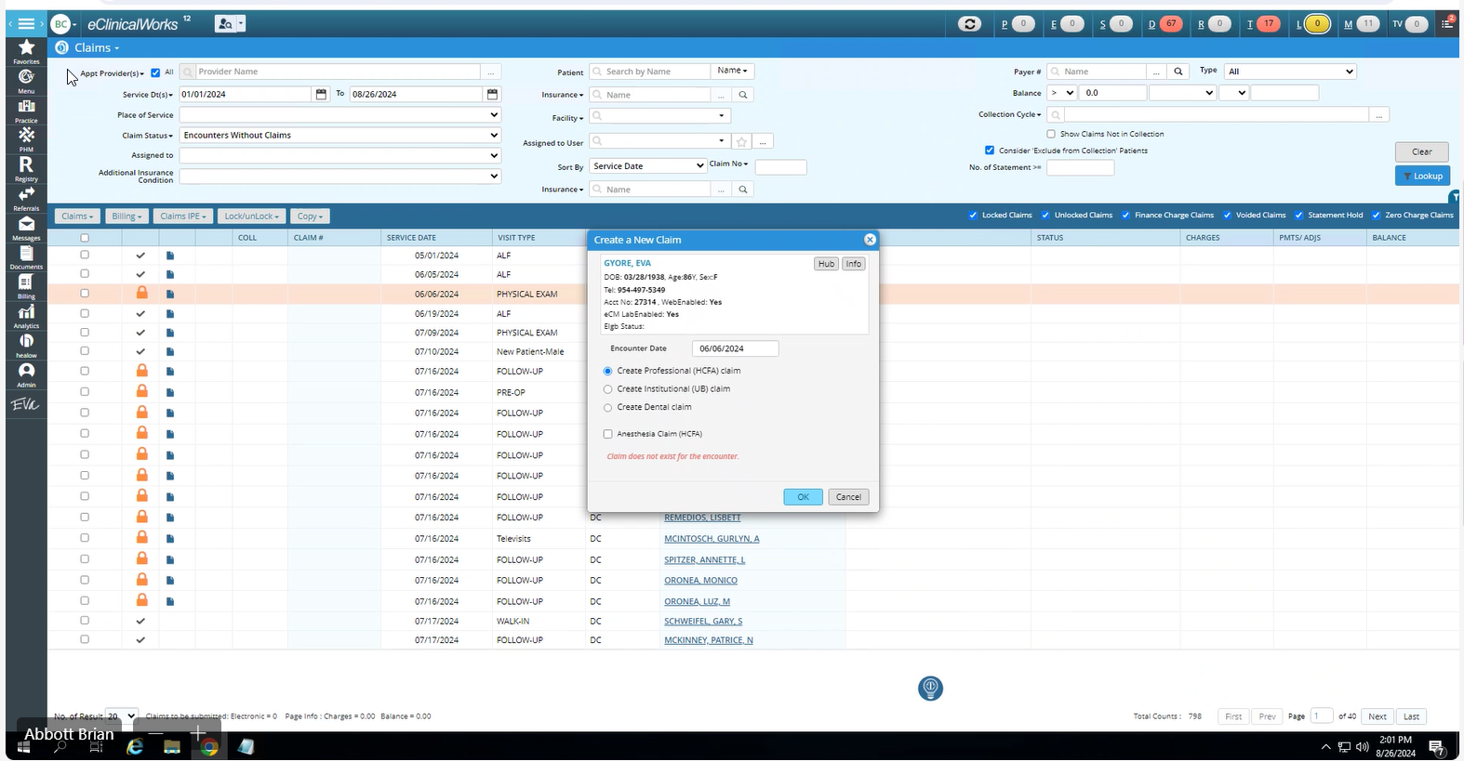

Figure 13- Create a New Claim

1. Billing >> Claim >> Create Claim

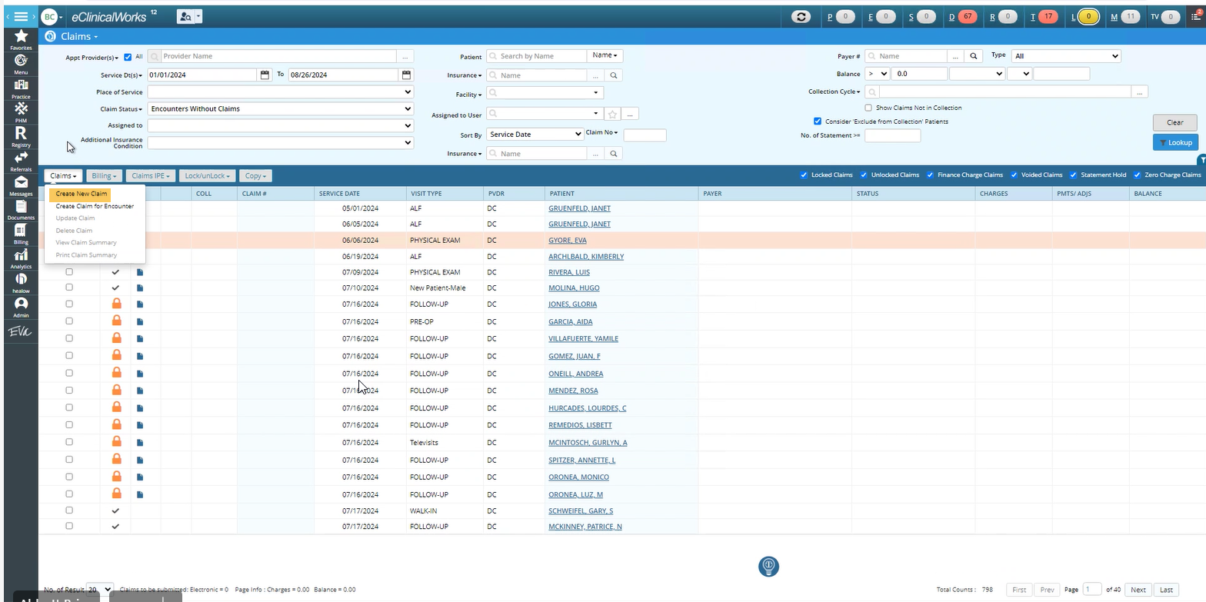

Practice > Office Visit> progress note> Claim

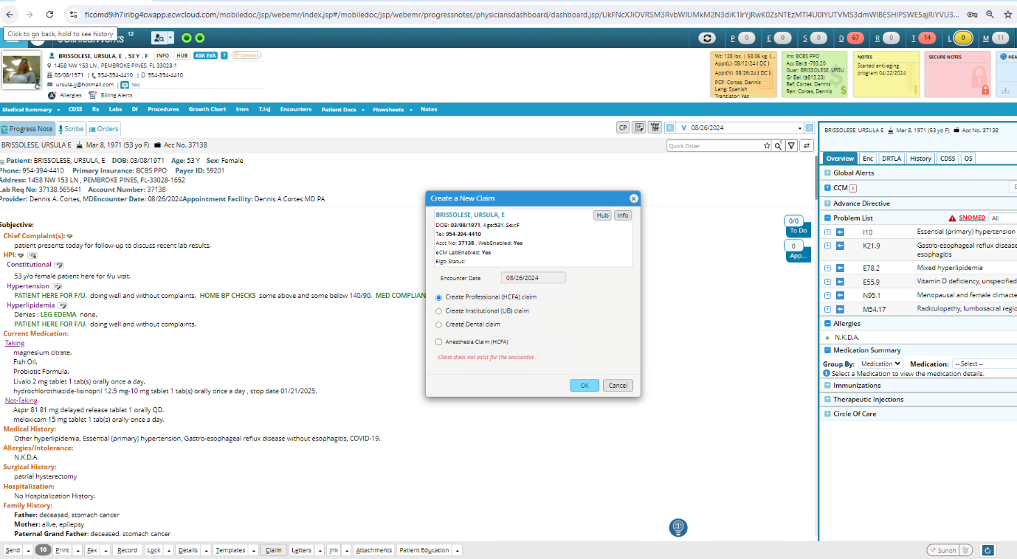

Menu >> Billing > Create Claim

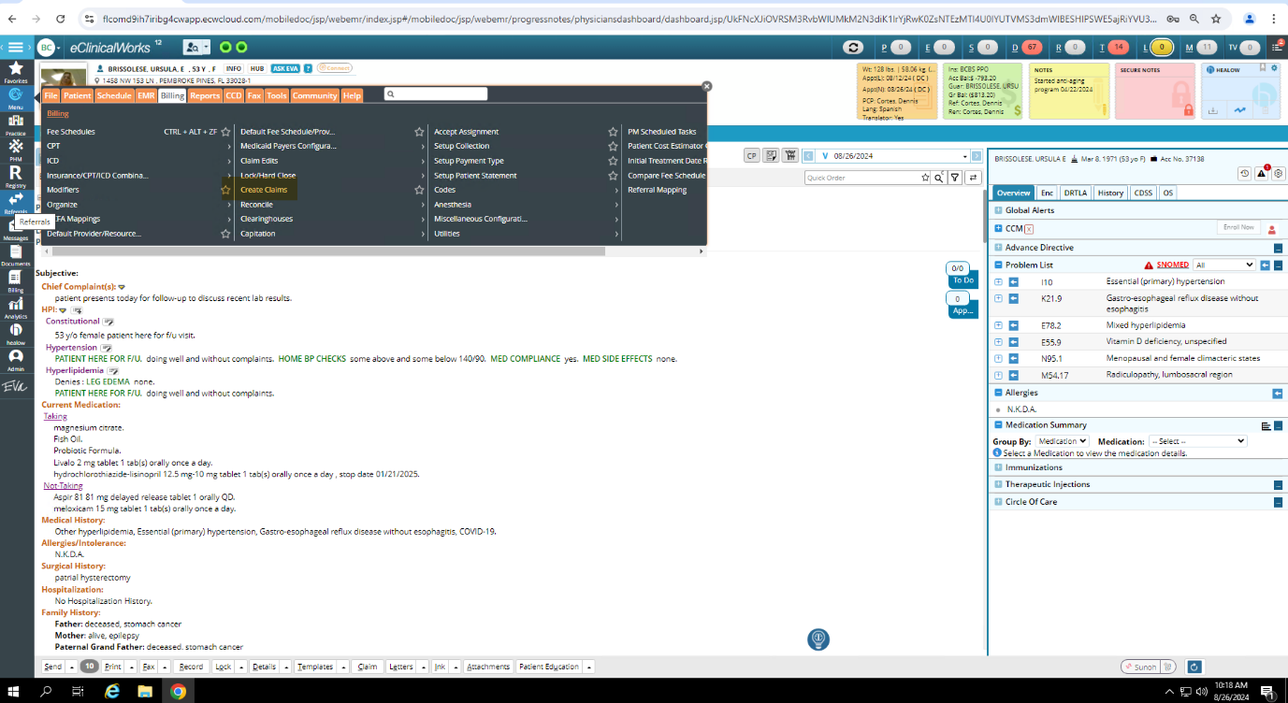

## **Claim Submission:**

1. Billing >> Claim >> Status = Ready to Submit >> Select Claim > Create Batch > Submission

2. Progress Note > Progress Note View > Claims > Create Claims for Encounter > Submission

Billing > Claim > Claims status > Select Ready to Submit > create batch > select clearing house

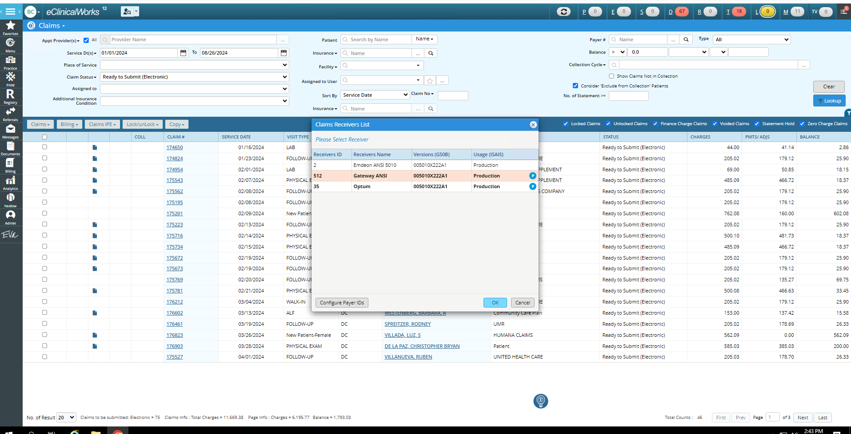

**Insurance payment**

Billing > ERA

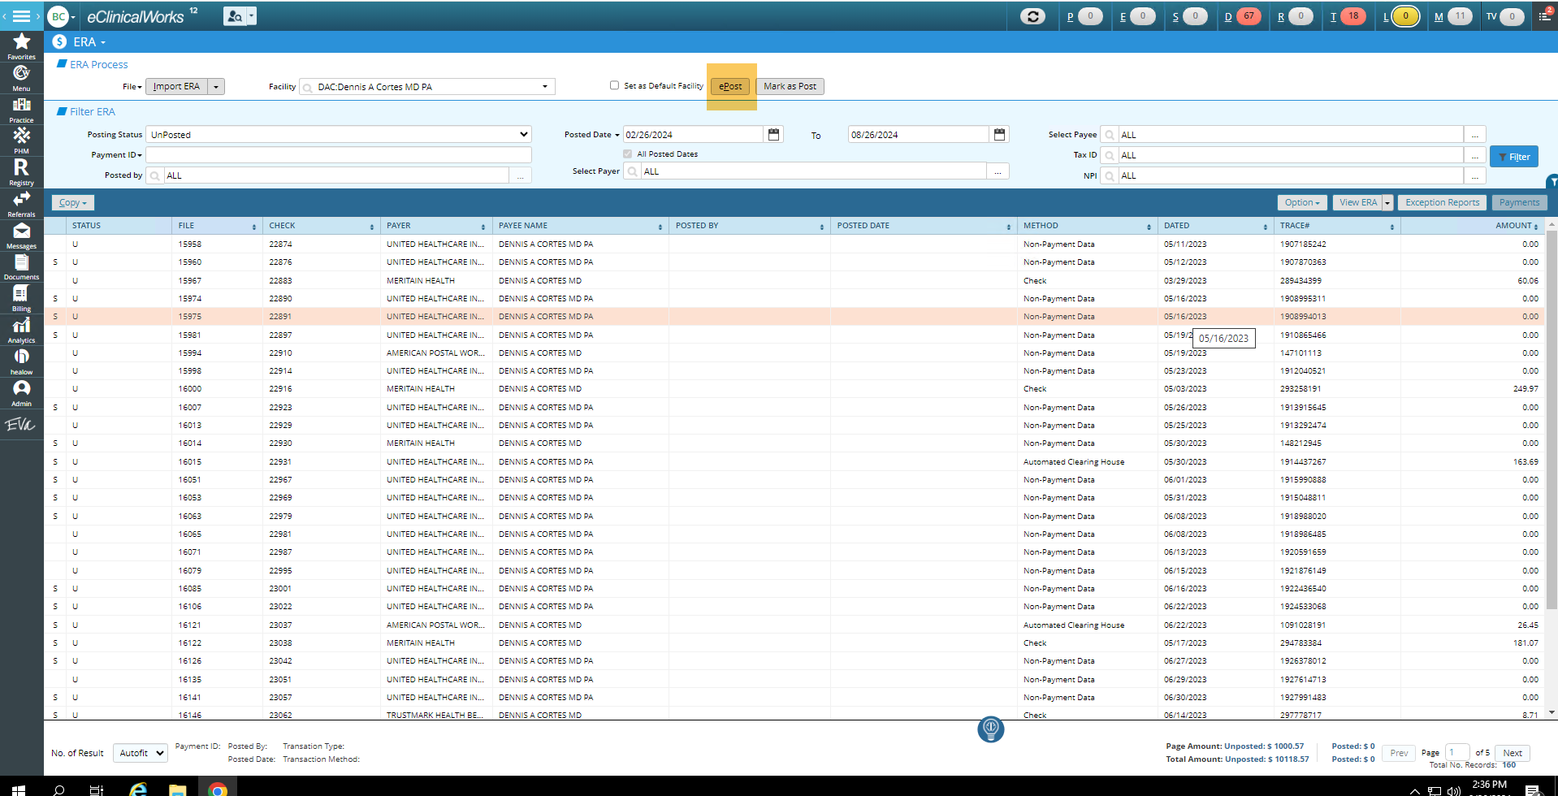

Billing >> File > Insurance >> Insurance Hub >> New Payment

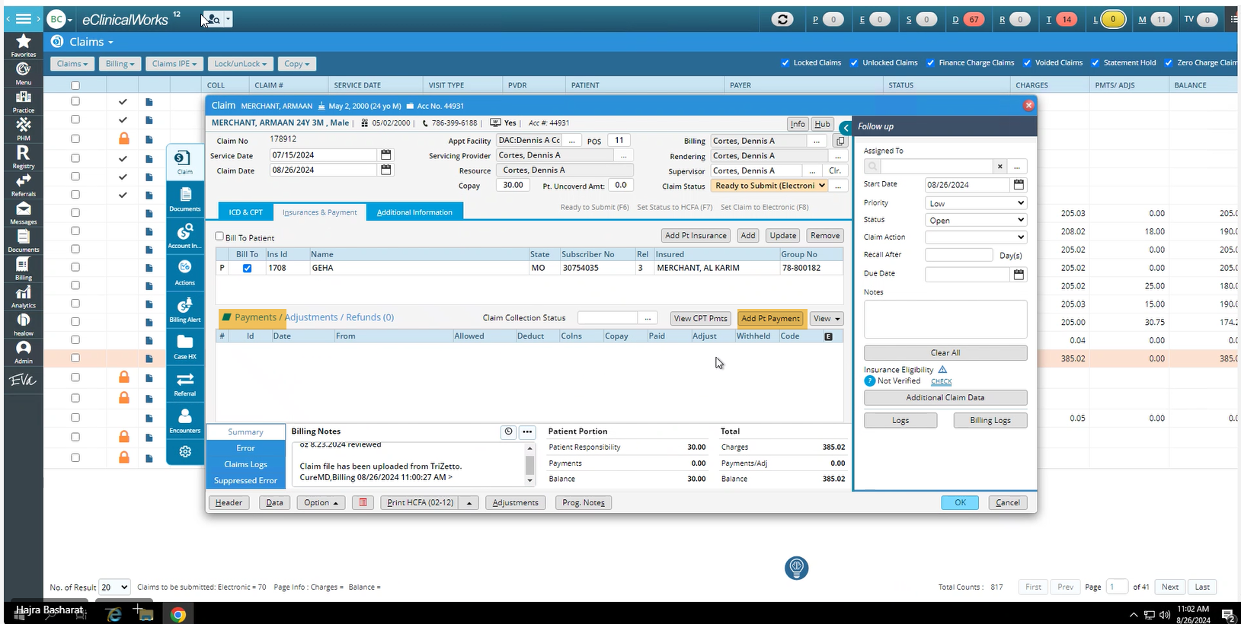

Billing > Payment >> Payment Batch

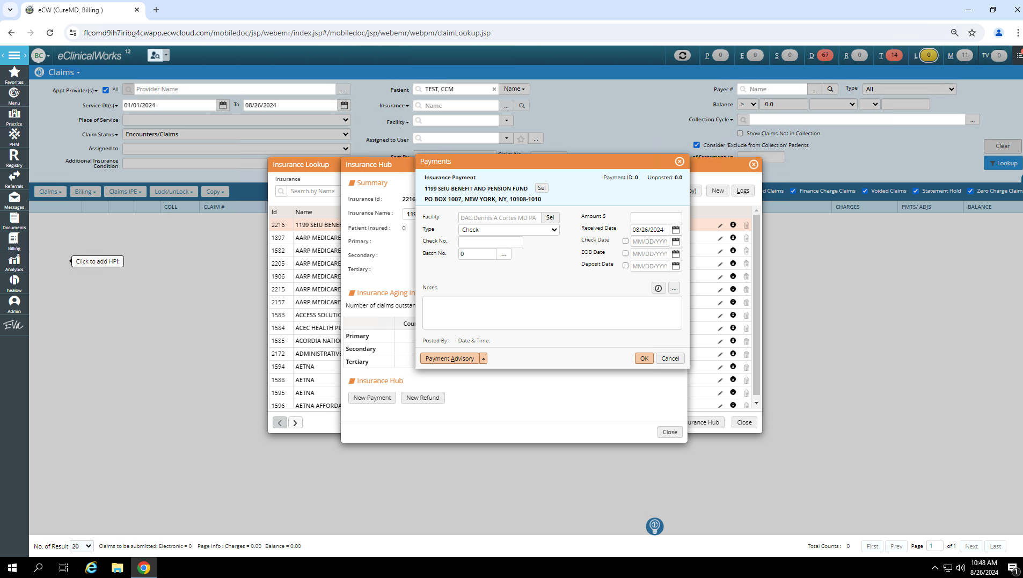

Billing > Payment >> Single Ins payment

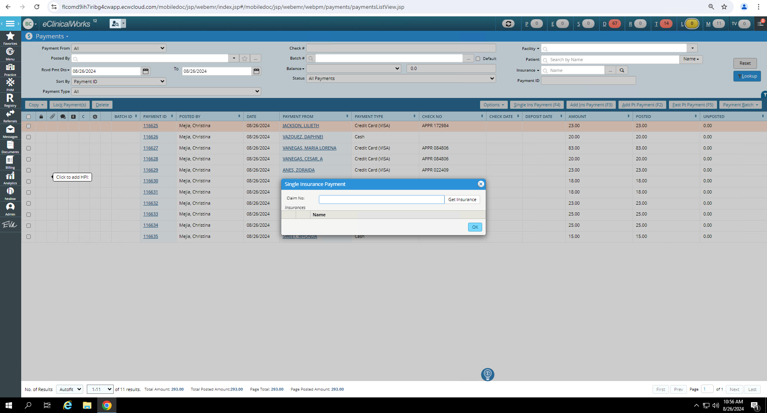

**Patient Payments:**

Patient Profile >> New Appointment > Copay

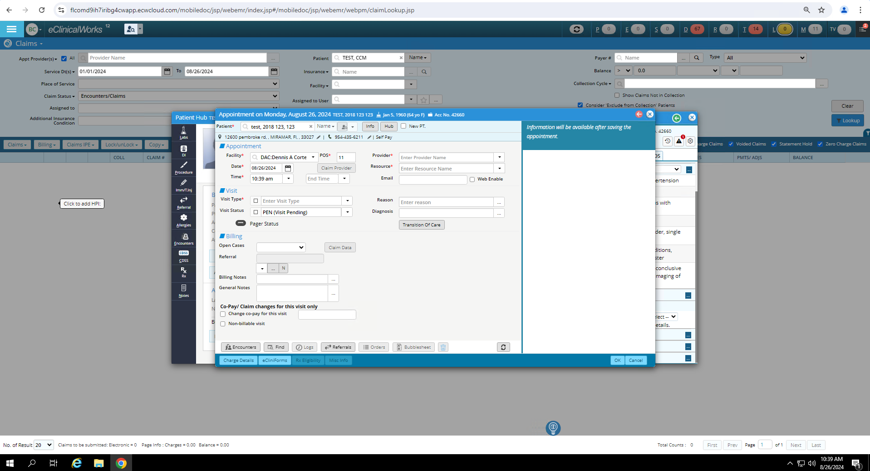

Patient >> Guarantor Balance >> Add patient payment

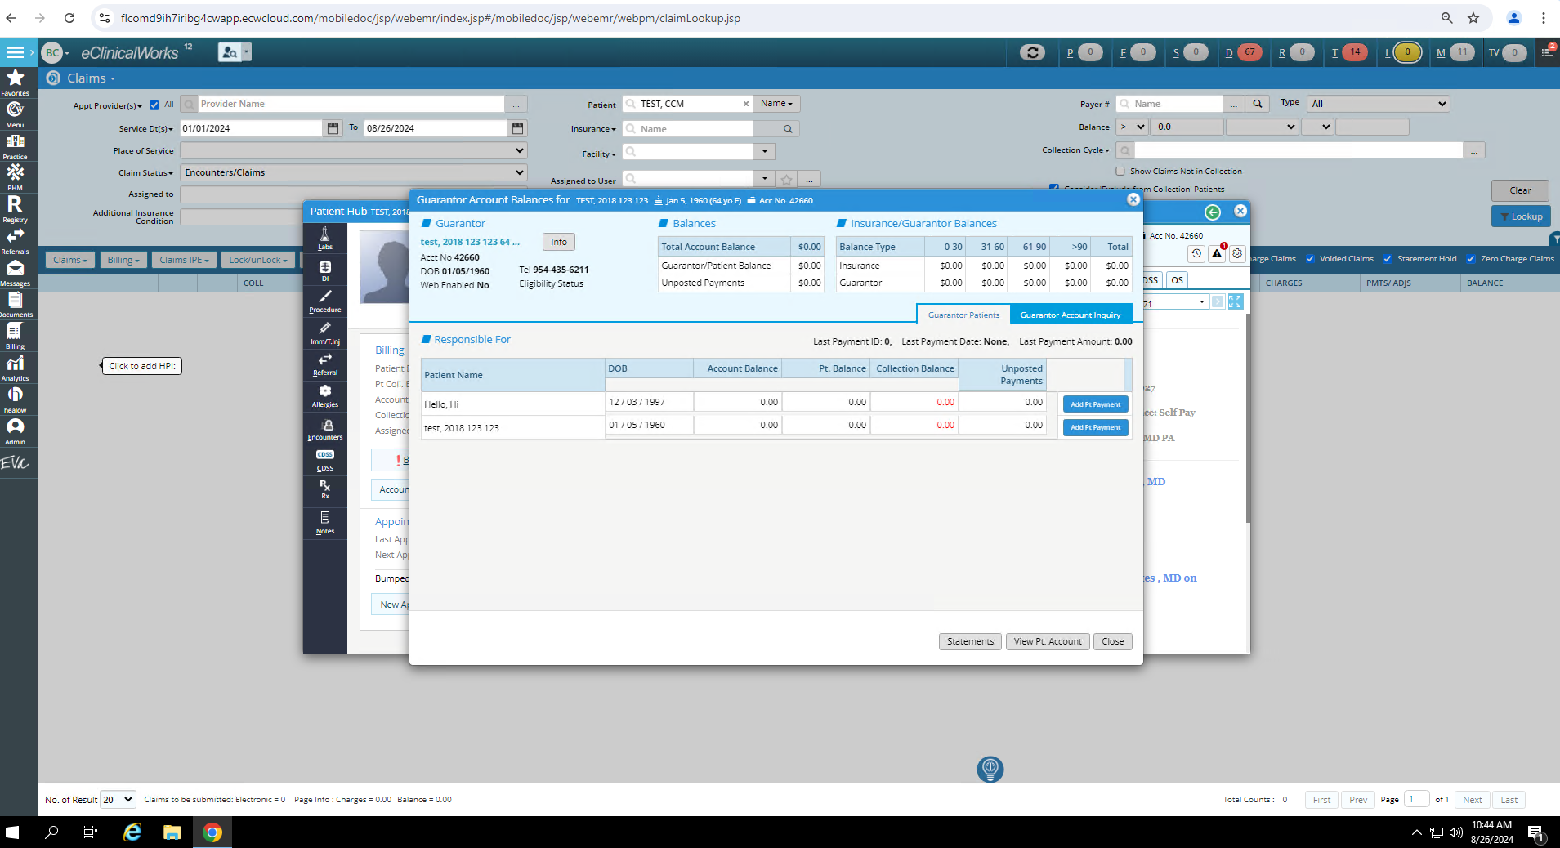

Billing > Payment >> Add patient payment

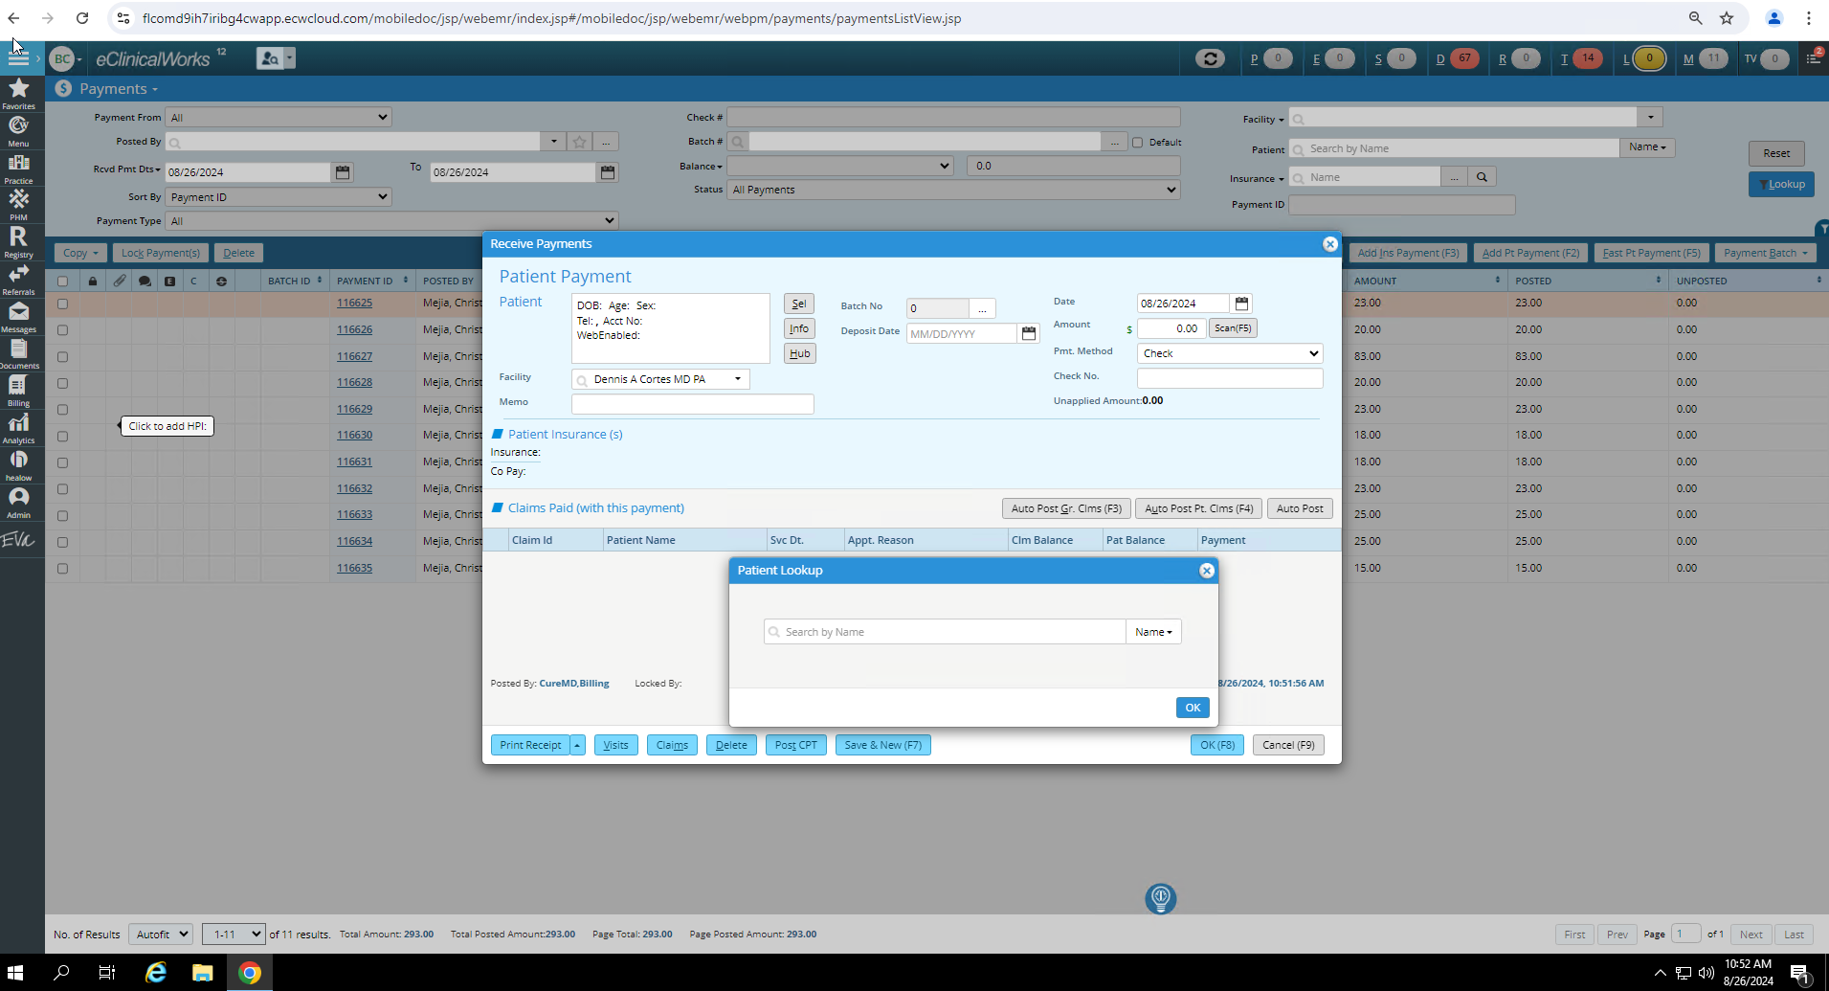

Billing > Payment >> Fast pt payment

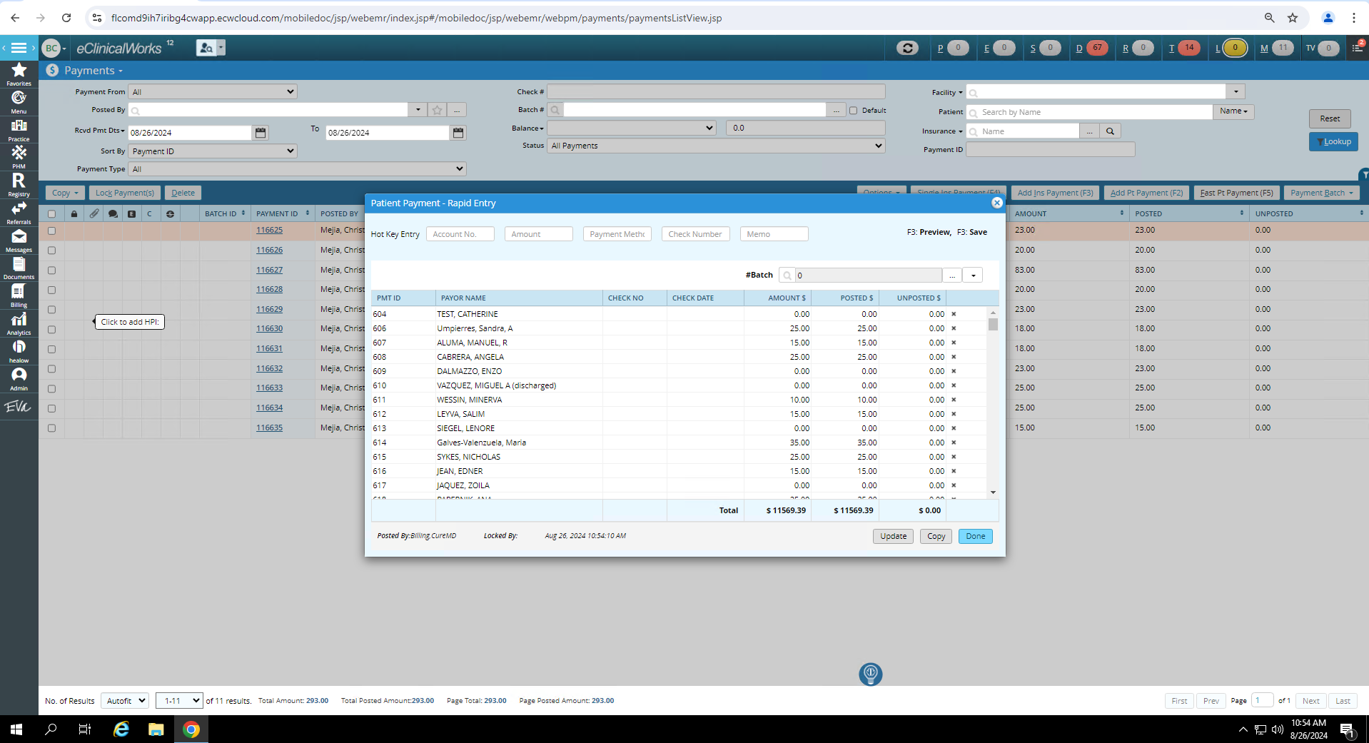

Billing >> Encounter >> Create Claim from locked > Insurance payment/Add patient payments



**Refund:**

Billing >> File > Insurance >> Insurance Hub >> New Refund



**Claim Denials**

Billing > Claim > Claims status > ERA Payer Denied

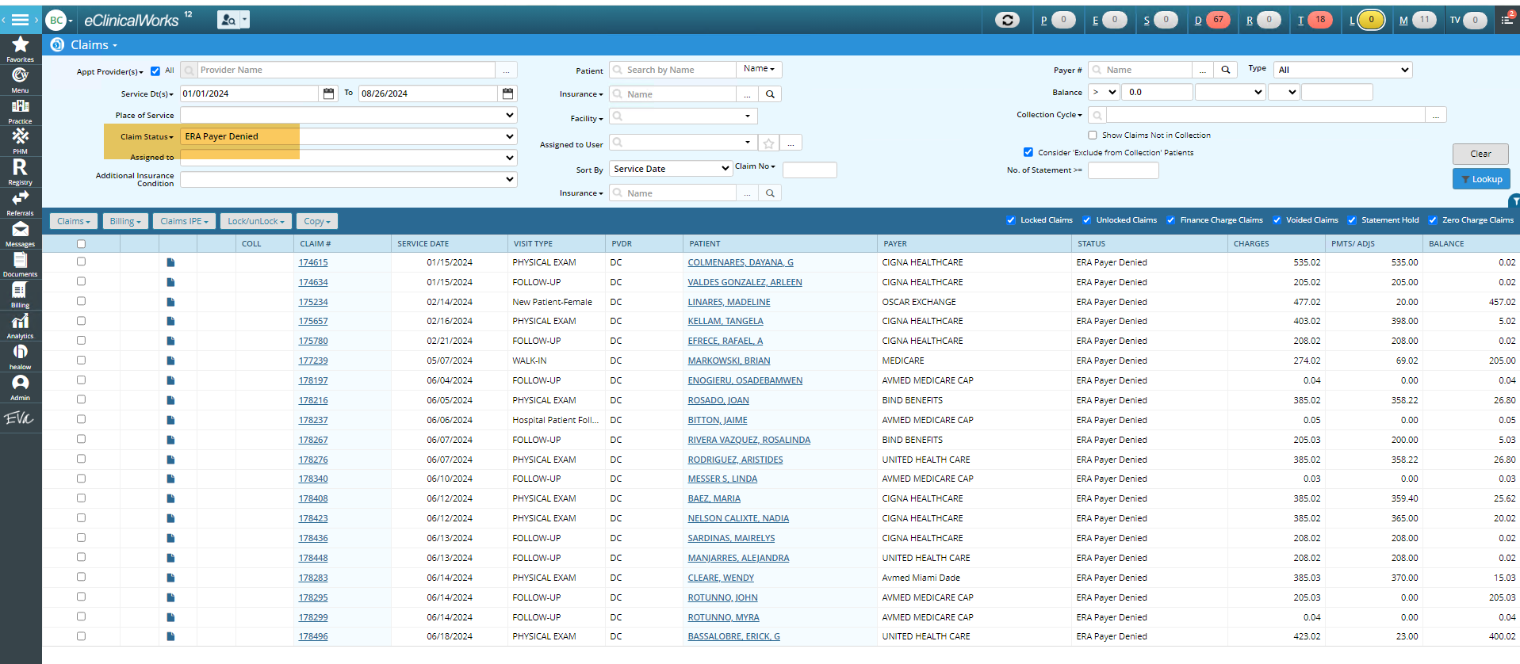

**Analytics** > Select Domain > Claim

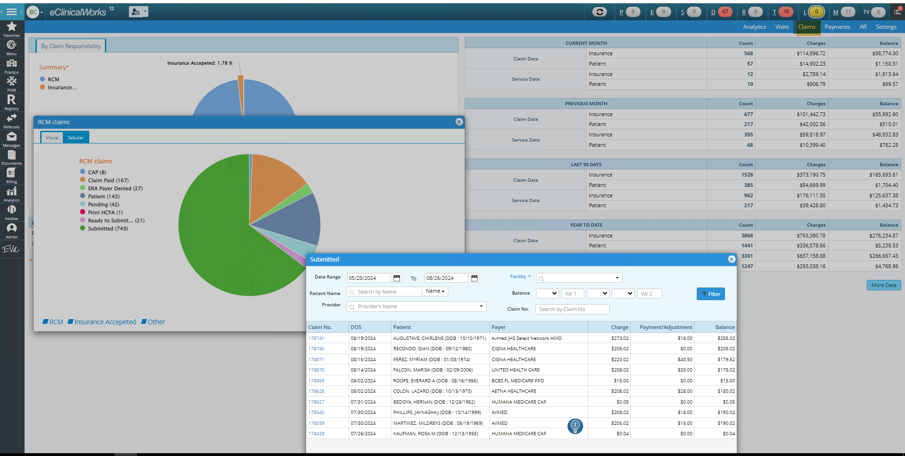

**Patient Cost estimator**

Billing > Patient Cost Estimator

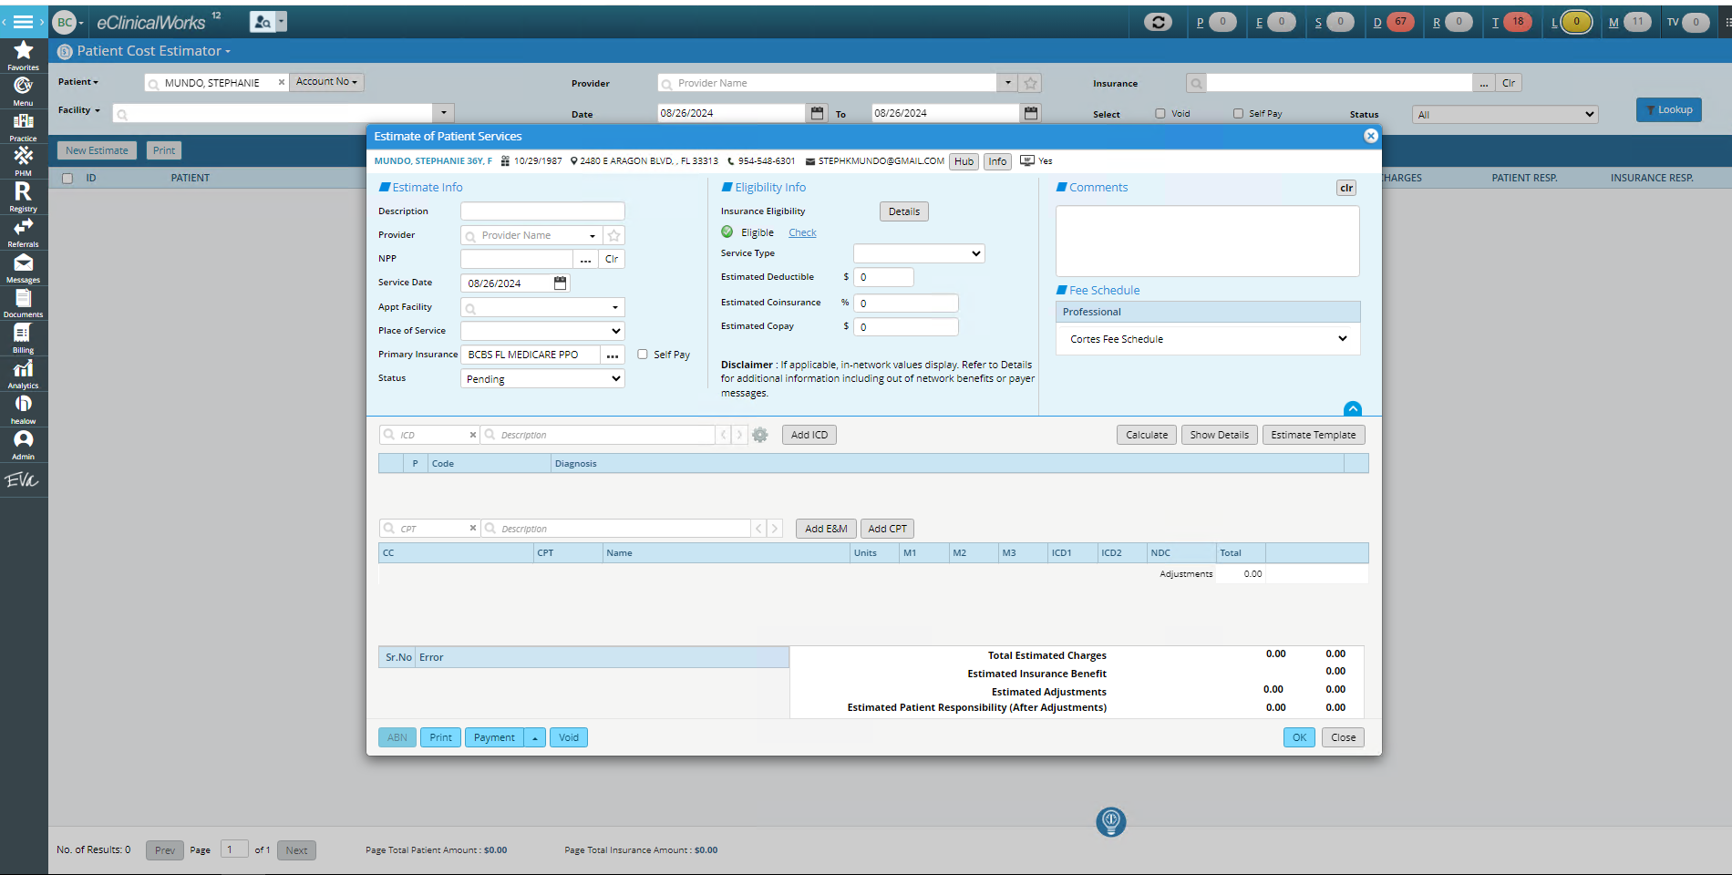

# **Greeway**

## **Patient Registration**

Patient can be Registered from 2 workflows:

* **New Account Creation (**All the information will be required like, plan name etc.**)**
* **Quick Register** (only captures the basic info but can add plan and other information when required, later on by edit option)

Patient>>Register>>Next>>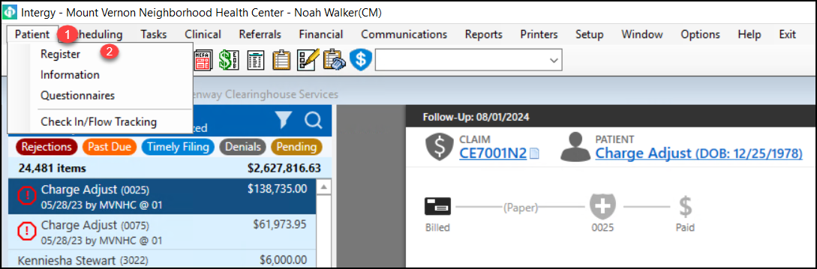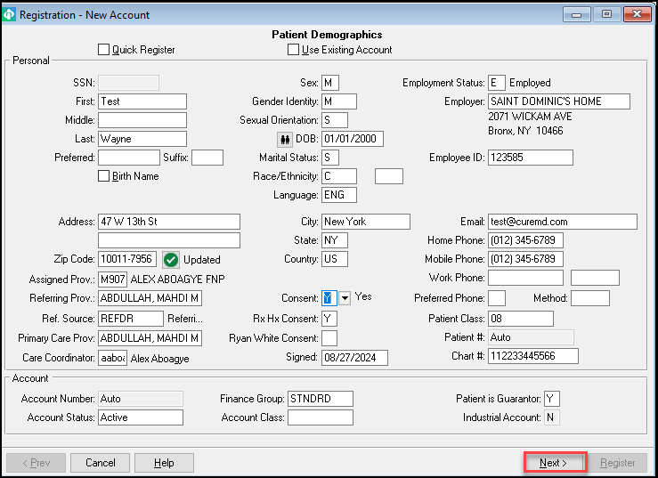

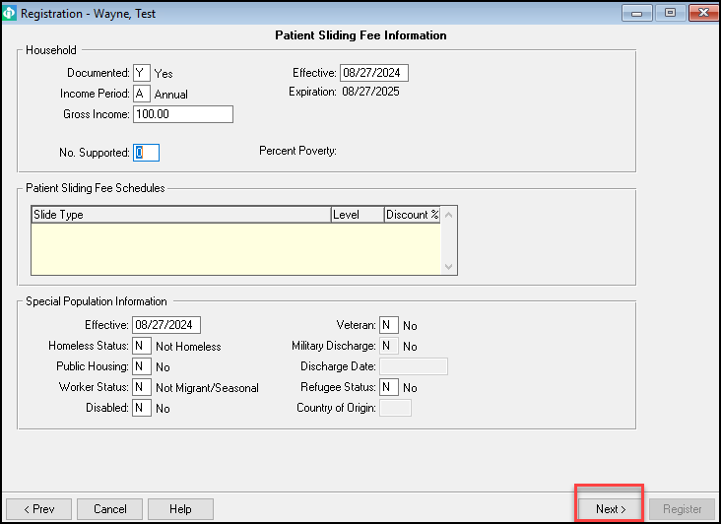

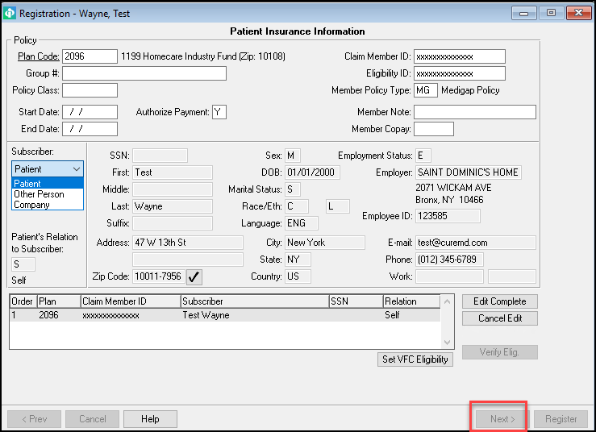  
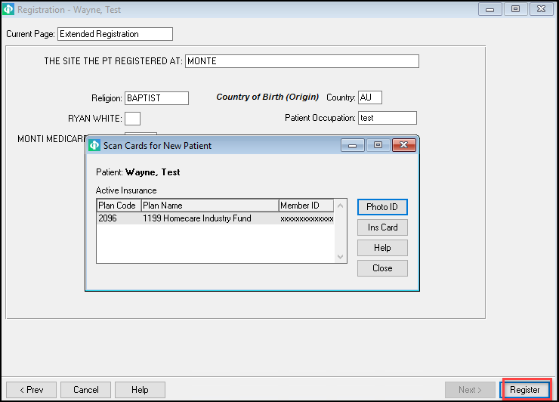  
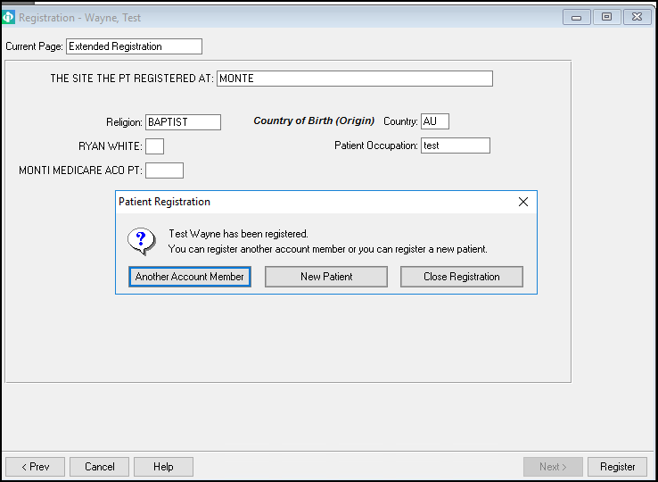

Note: Patient has been Registered.

**Quick Register:**

Just add the Patient Information, account has been registered.

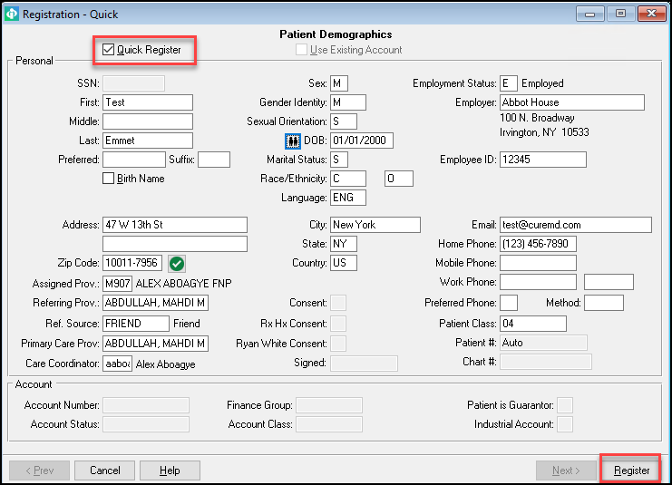

**2.Patient Lookup:**

Click on patient Icon. Search Patient with different option (Name, SSN, Phone, DOB, Patient#, Account#, Chart#, ID)

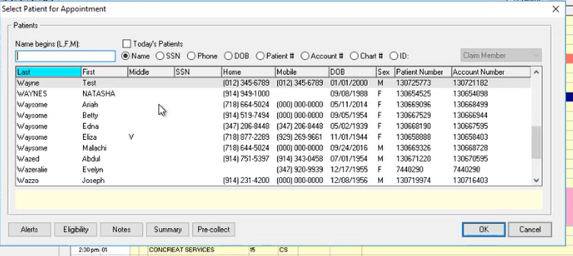

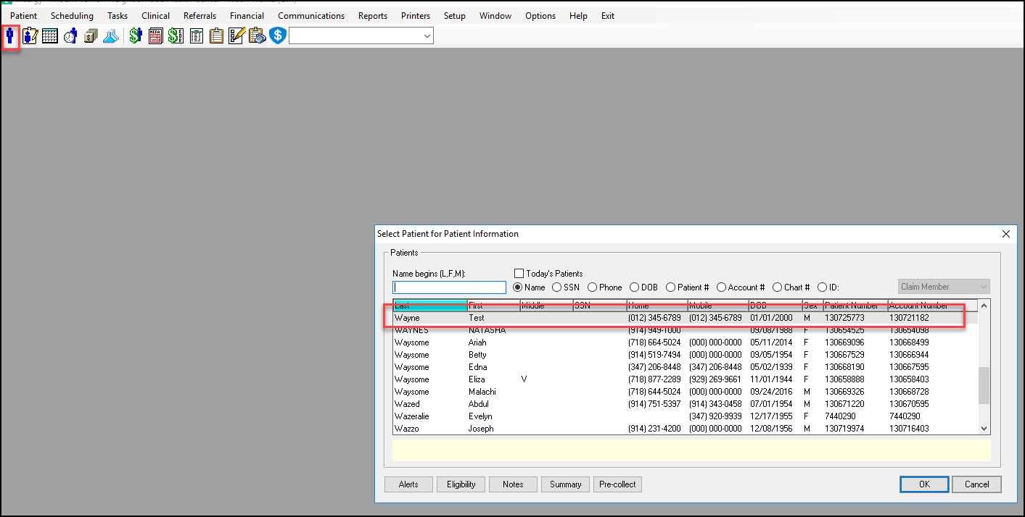

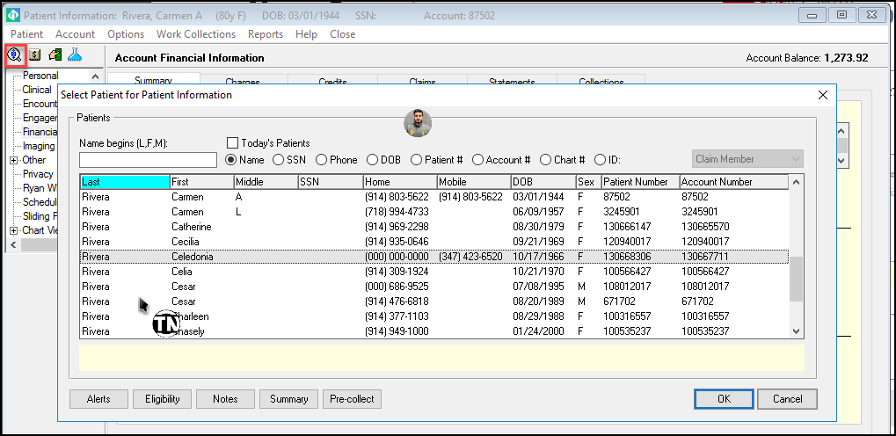

Above red circled option is used to lookup a registered patient, anywhere it is shown like above, can be used as patient lookup tool. This is from charge page.

## **Scheduling**

There is an icon to navigate to the Appointment Schedular.

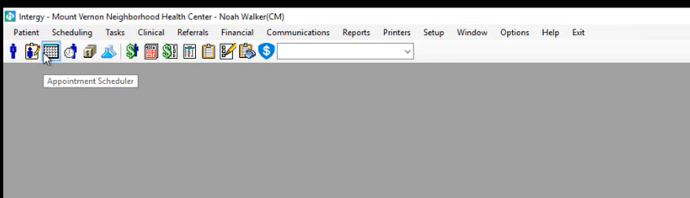

Another workflow to Appointment Scheduling🡪   
The user clicks Scheduling >> appointments, to open the Appointment schedular.

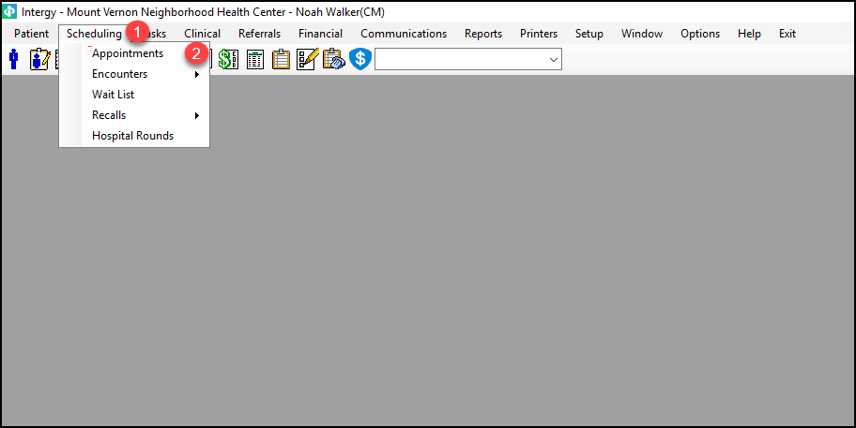

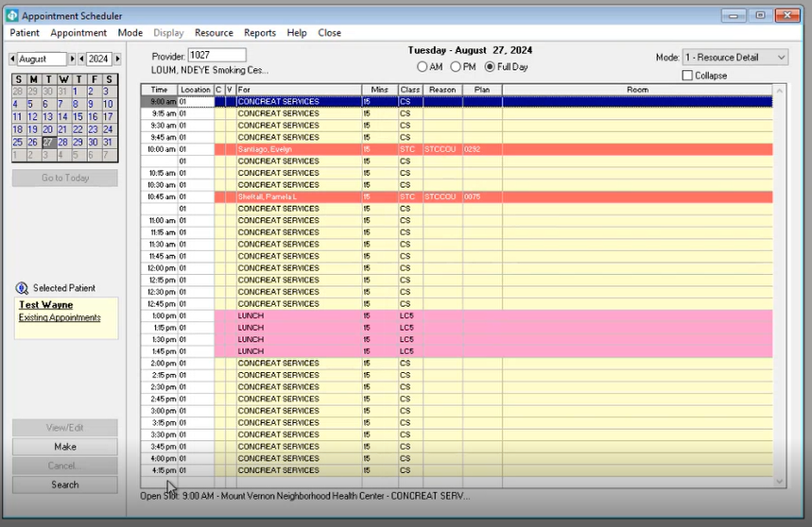

When the user clicks on an empty slot, a patient selection screen is displayed.

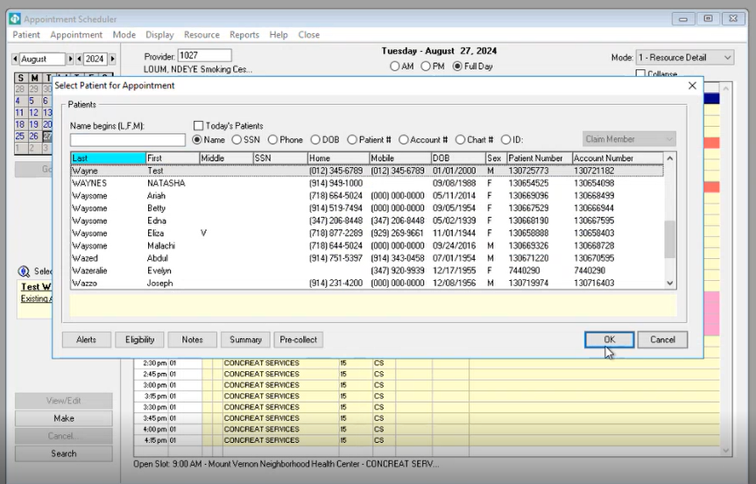

On selecting a patient, the “Make Appointment” pop-up is displayed.

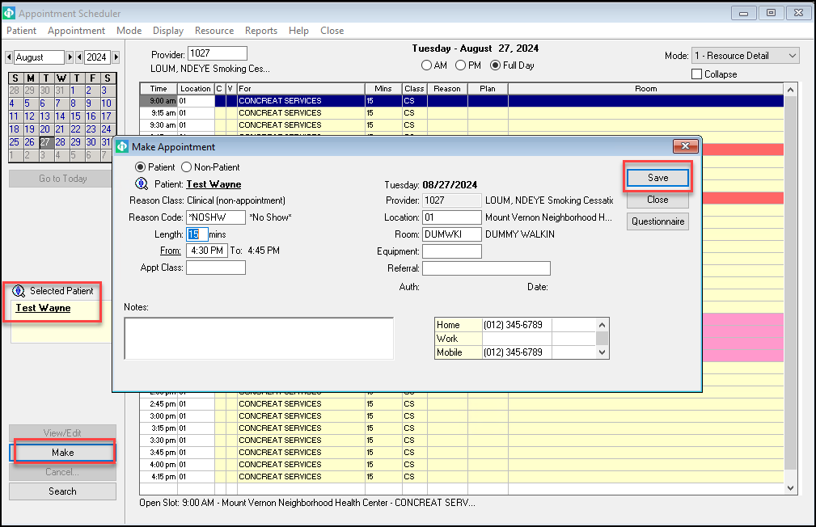

There is a reason class and reason codes. There is an option to create new reason codes.

In CureMD, there is a reason but no “reason code” for appointment booking. There are no “reason classes”.

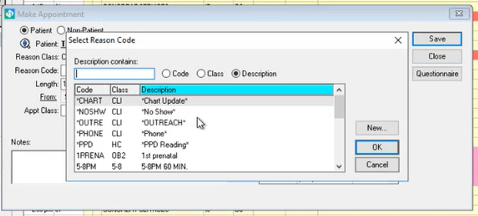

There are practice specific Appointment Classes. There is an option to create new Appt. classes.

CureMD does not have appointment classes.

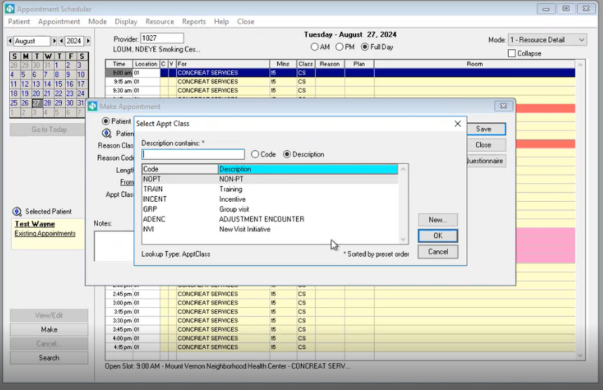

There is an option to Select Appointment Equipment.

CureMD does not have an option to Select Appointment Equipment at Appointment booking. We have a separate resource schedular.

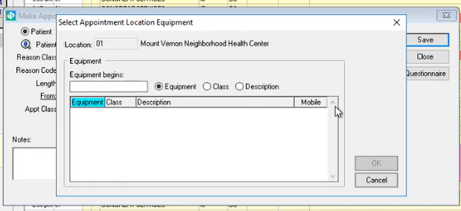

The user can select a Referral.

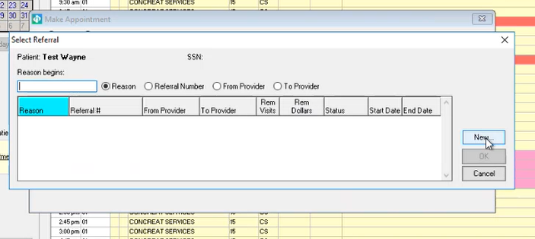

There is an option to select the questionnaires. It is using the reason class and there reason code.

CureMD does not have an option to “select the questionnaires” **at Appt. booking**.

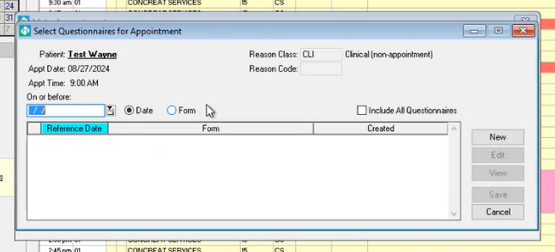

There is an option to search the Appointment.

CureMD does not a similar Appointment Search catering reason/room/provider/equipment.

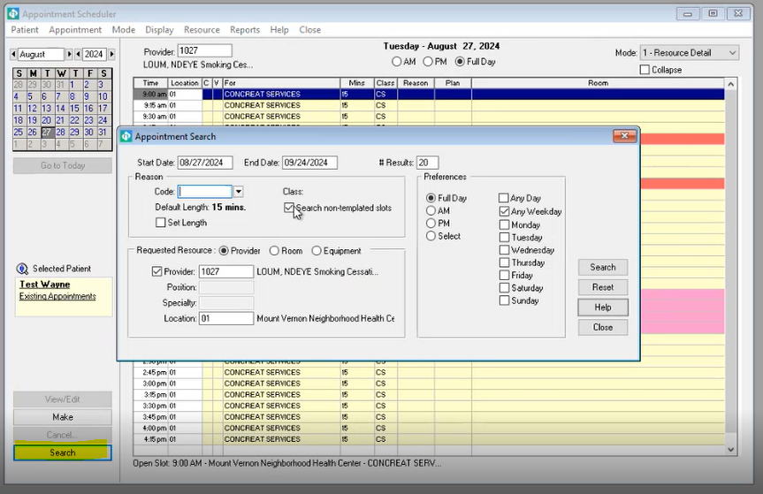

On a booked appointment, there are the following options:  
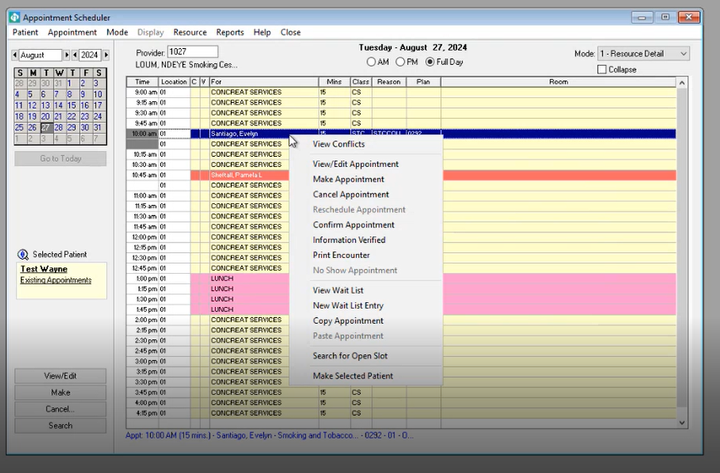

CureMD does not have the option to “View Conflicts” while booking the Appointment.

On-clicking view/edit appointment

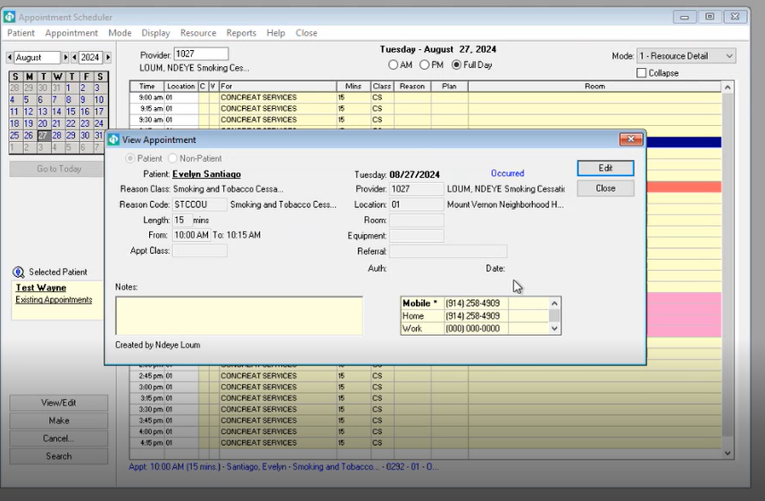

On clicking “Make”, the appointment is confirmed.

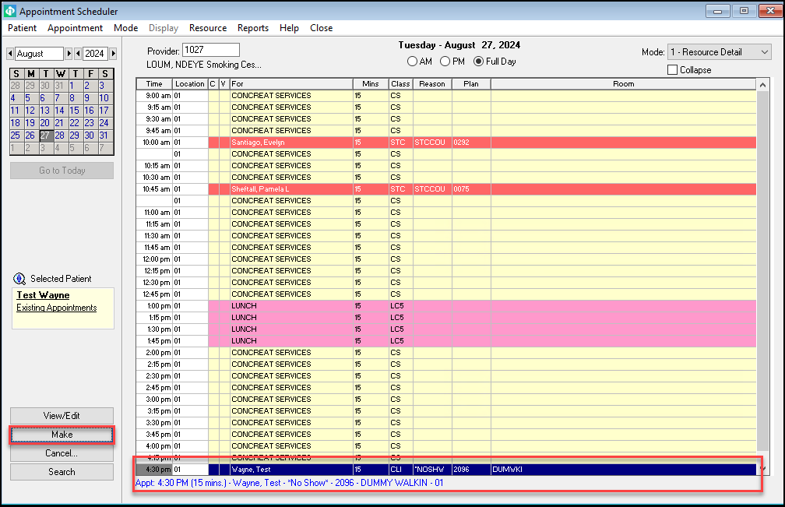

Click on Reports >Daily Eligibility, the daily eligibility report is generated.

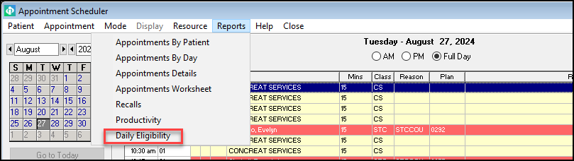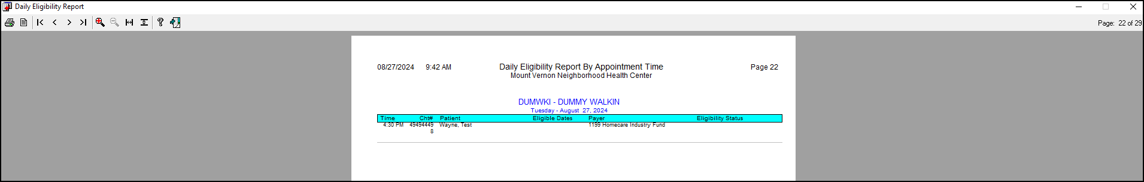

Once patient is scheduled he/she showing in Patient Flow Tracking.

Patient>>Check in Flow Tracking>>Find Patient

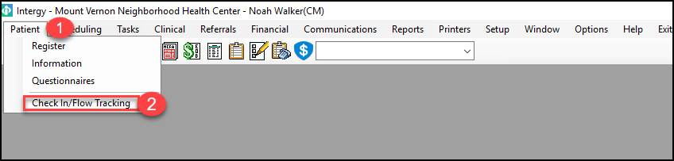

CureMD does not call this Flow Tracking. CureMD has a better view!

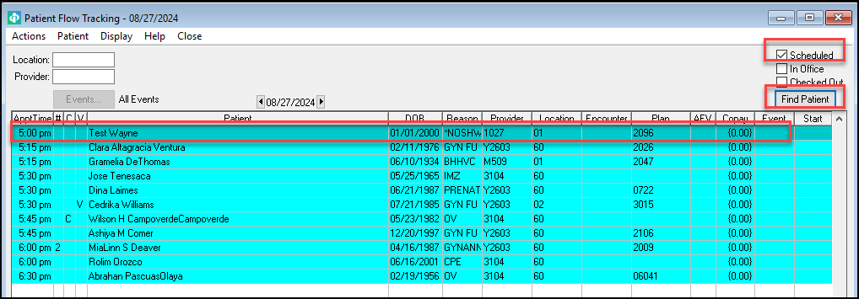

There is another workflow to view or edit or cancel the Scheduled Appointment. It does not allow to schedule a new appointment.

Claim Control >> Select Claim Identifier >> Account Financial Information >> Scheduling

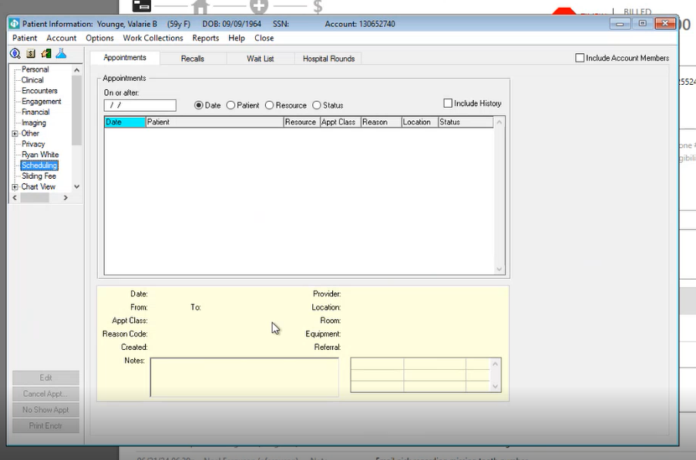

Check the “Include History” Check Box to view the Appointment History of the Patient.

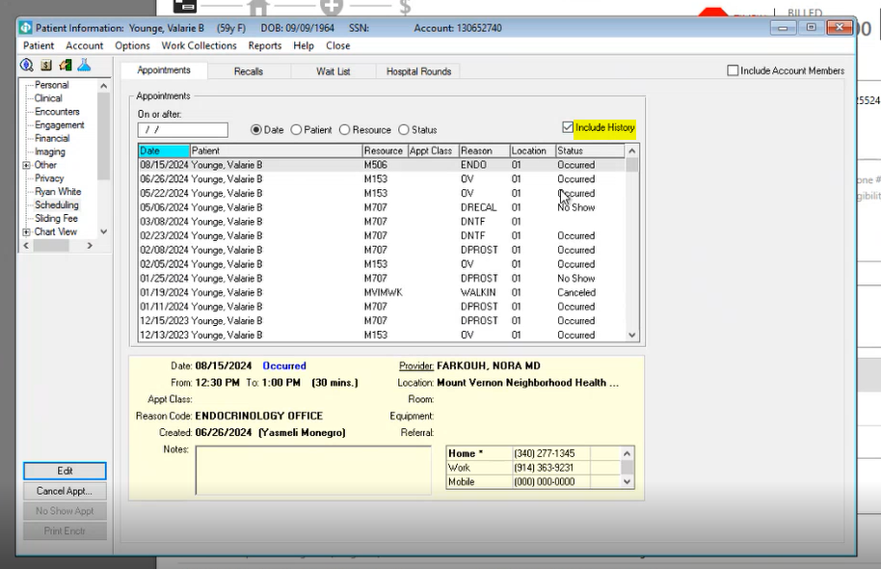

There is another option related to Scheduling. On-clicking “Reports” from the top navigation bar, there is a Scheduling option.

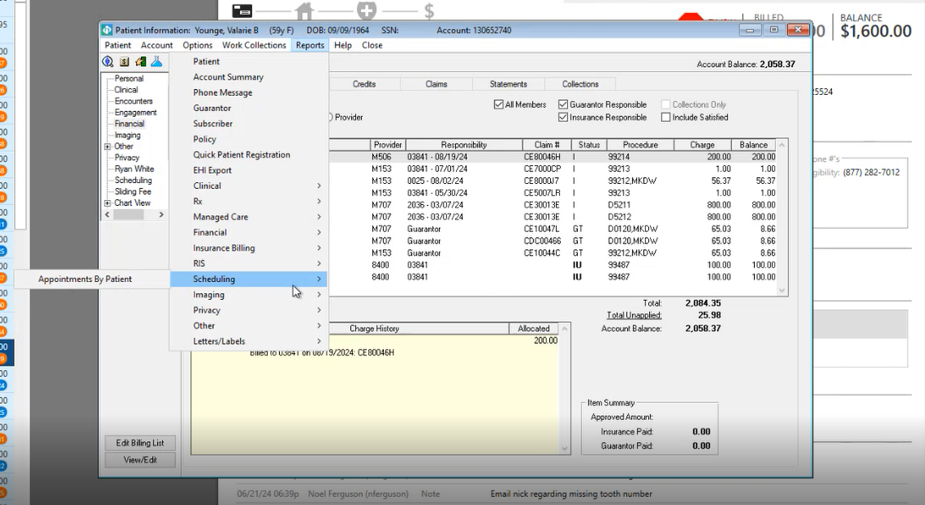

On-clicking “Appointments By Patient”, a pop-up is displayed

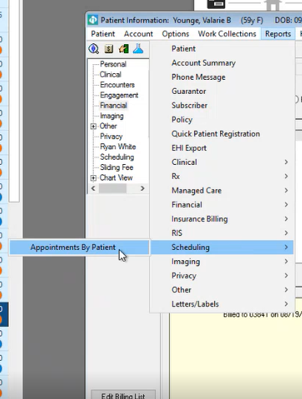

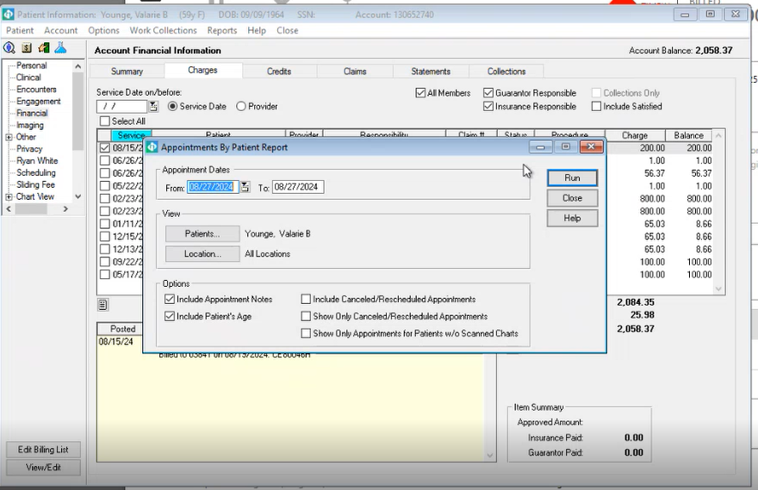

## **Charge Creation**

On-clicking the Claim Control Icon,

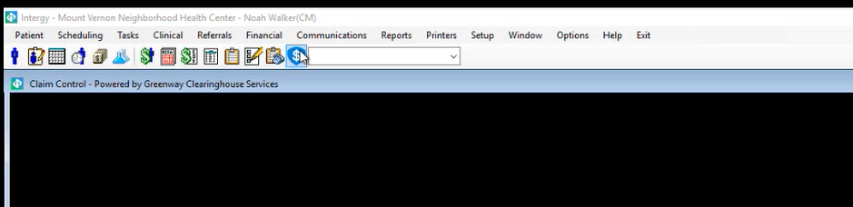

The “At Risk Claims” are displayed.

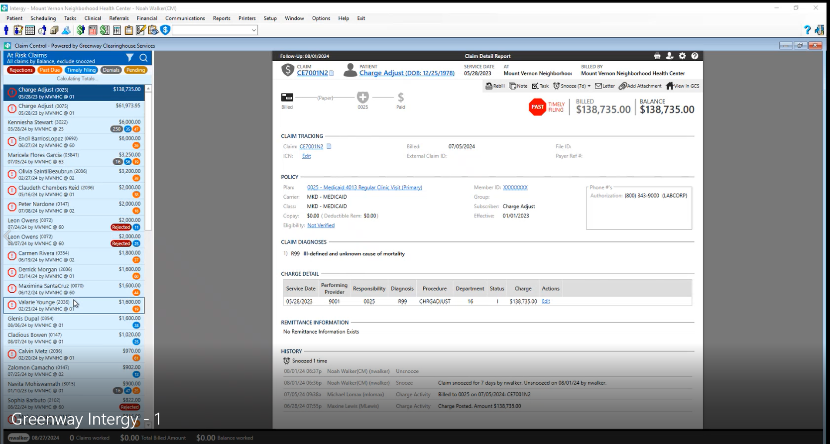



On-clicking the claim ID, the Account Financial Information opens:

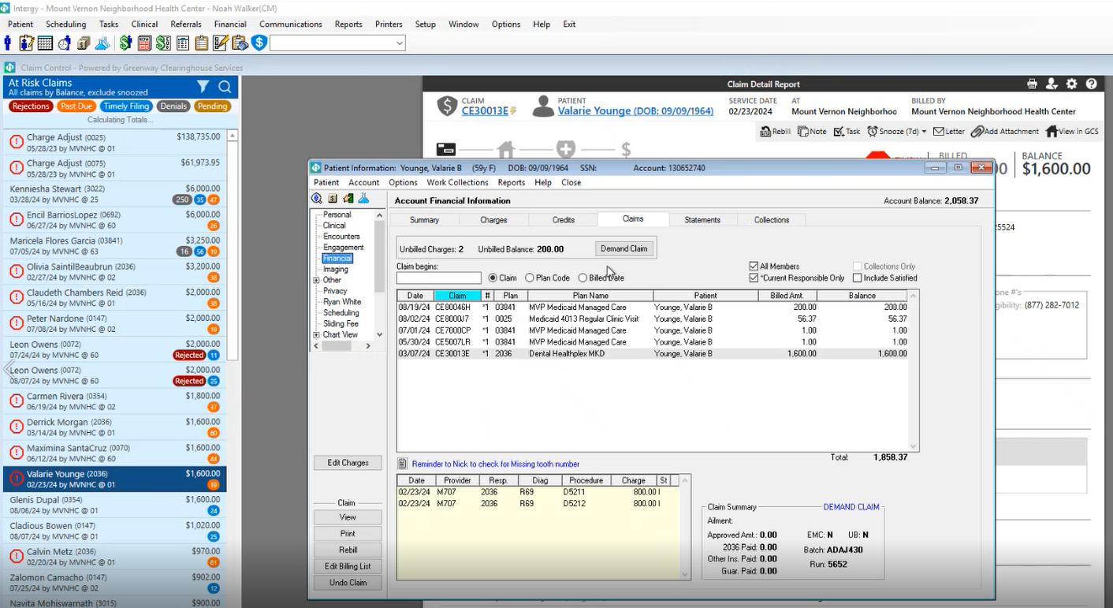

Change the tab to “Charges”

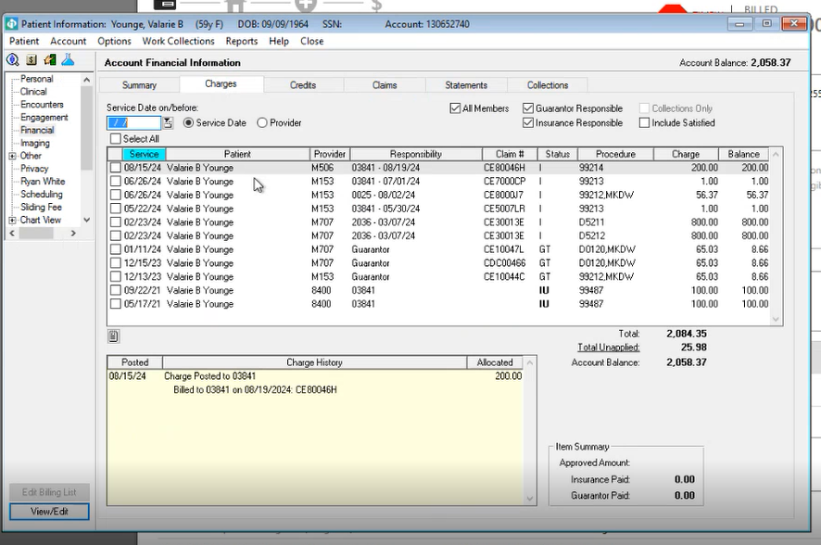

All charges with open balance are displayed. Check the “Include Satisfied” Check-box to see charges with close balance.

The box below displays the change history along with dates.

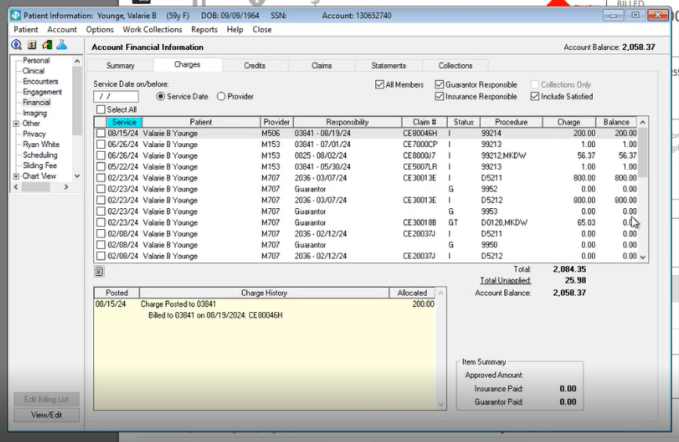

Unchecking the “All Members” check-box, displays patient specific Charges.

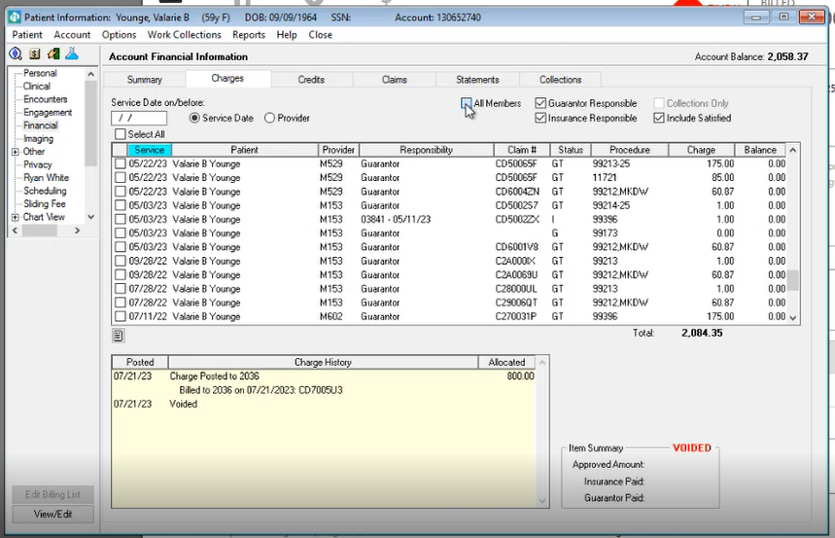

On clicking any charge, it opens in Edit Mode.

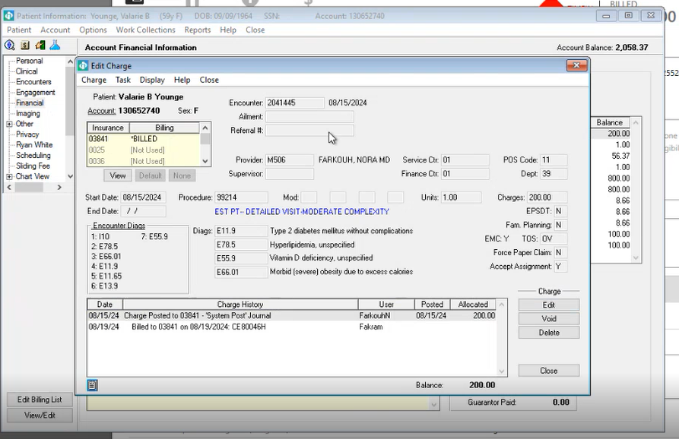  
There is a drop-down for Ailment. On-clicking, a pop-up opens:

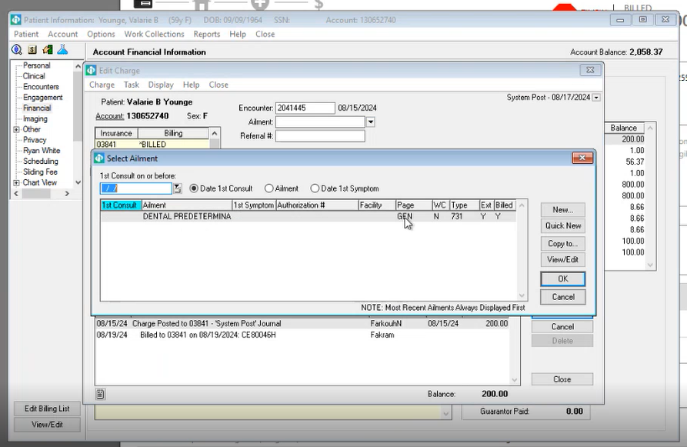

On-clicking the “Credits” tab, following is displayed:

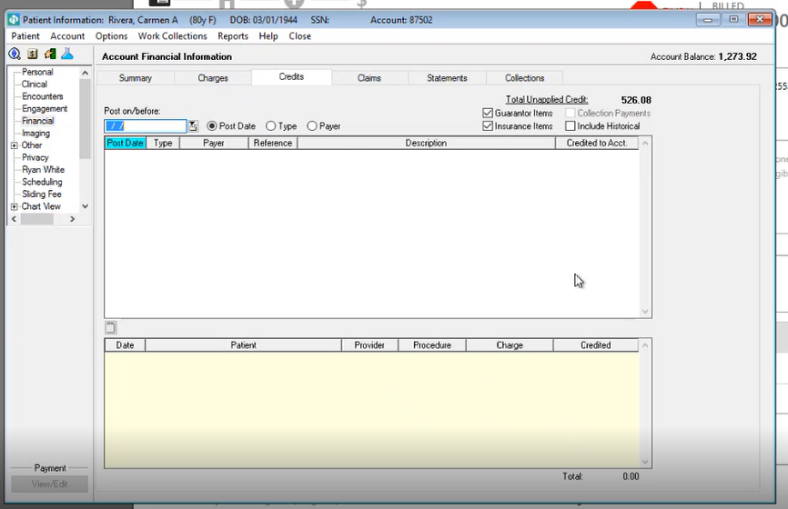

From the above window, the following options can be selected.  
  
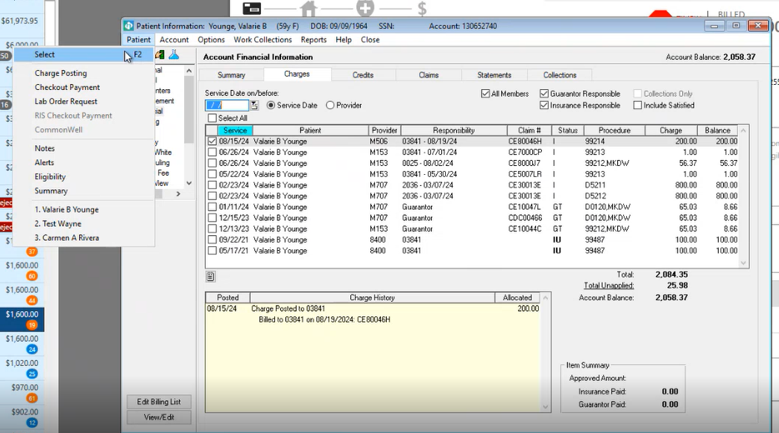

Under “Account”, following are the options:

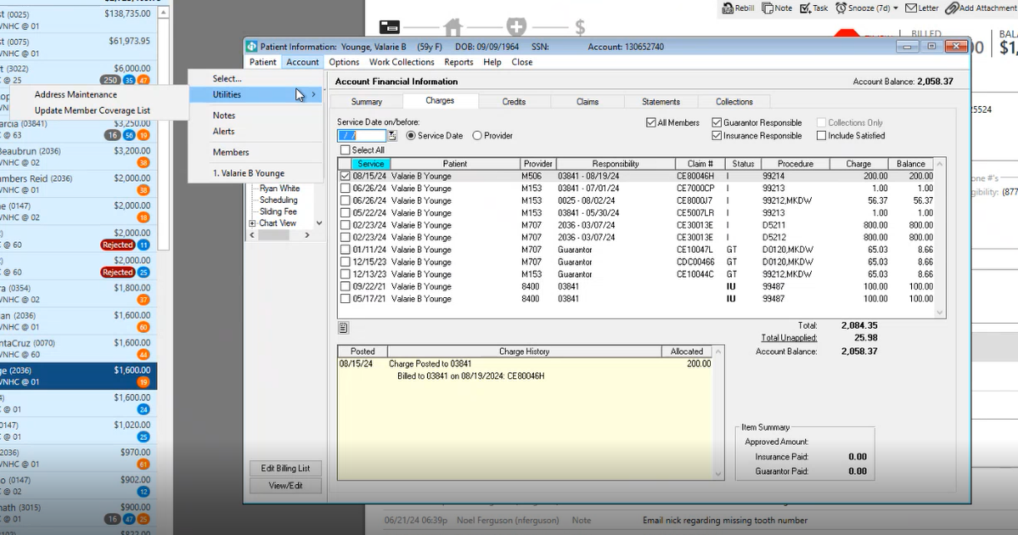

Under “Options”, there are following options:

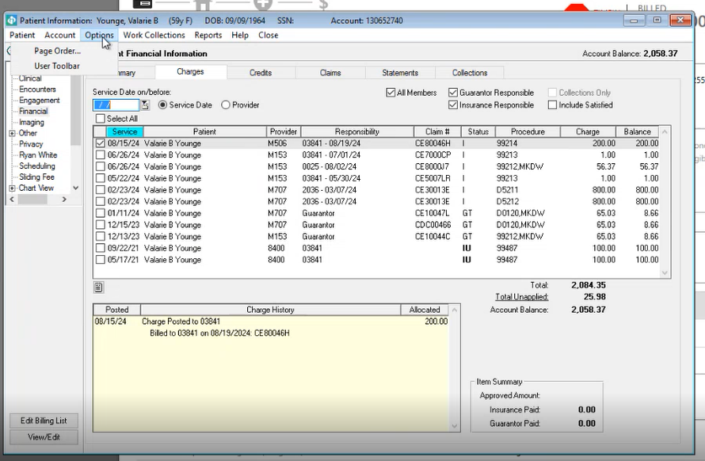

Under “Work Collections”, there are following options:

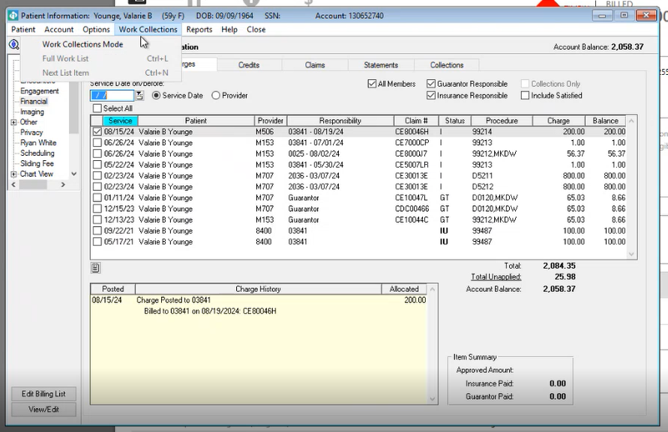

Under “Reports”, there are following options:

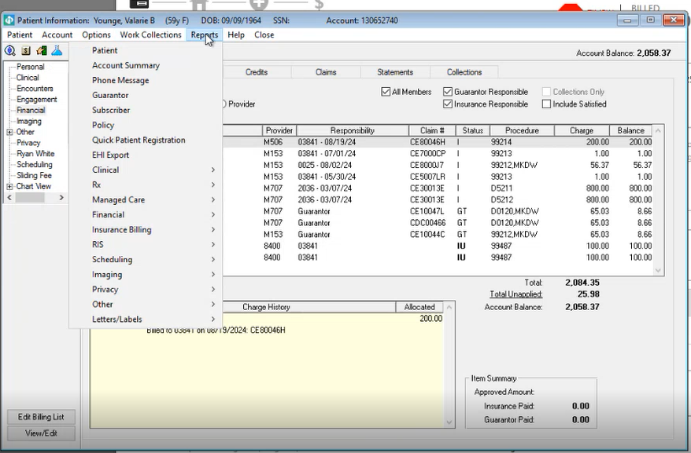

On expanding the drop-down options, following sub-options appear:

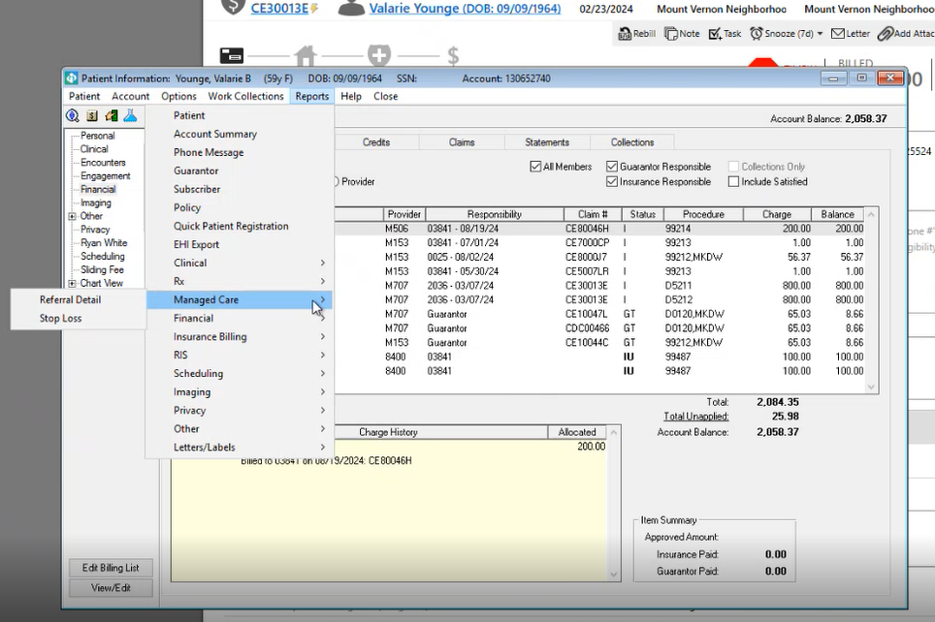

Under “Clinical”:

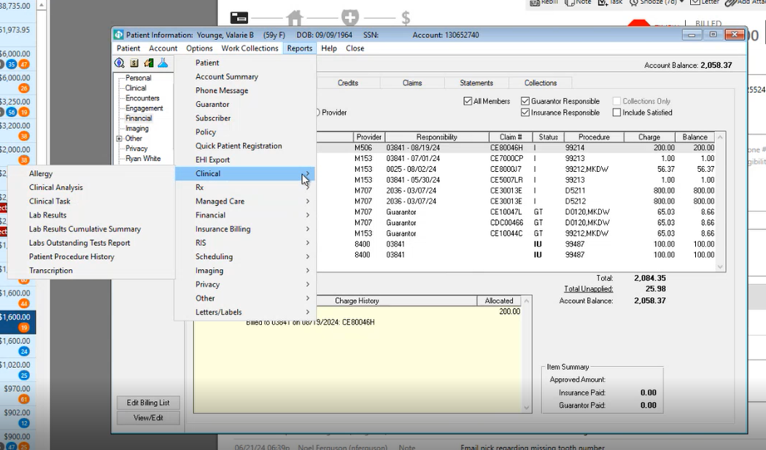

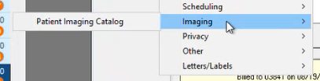

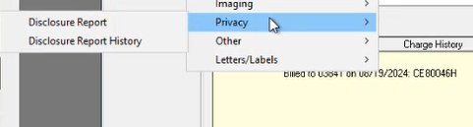

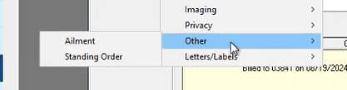

Charges can be created from 3 workflows.

* Charge Posting (Patient is scheduled and we can create a charge)
* Admin Charge Posting (This can be used for exiting patient accounts)
* Pending Charges (Charge is created but need to post into the system)

Charge Posting

Go to financial>>Charges>>Charge Posting>>Select the patient for Charge Posting>>OK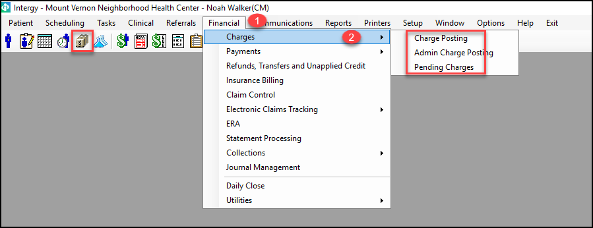

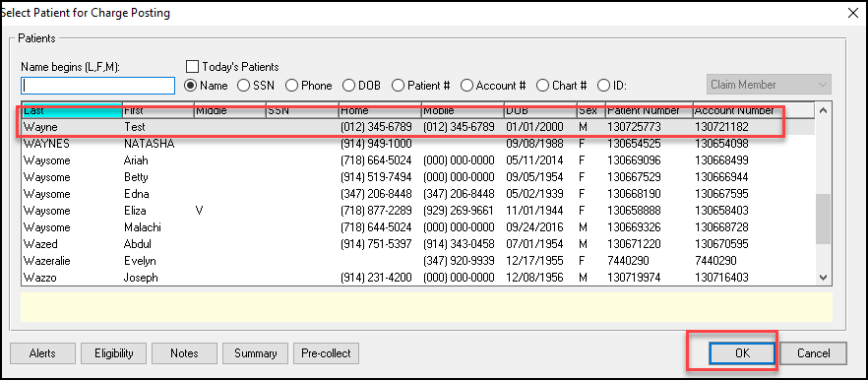

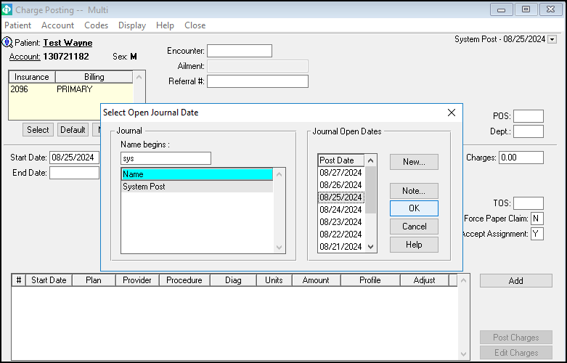

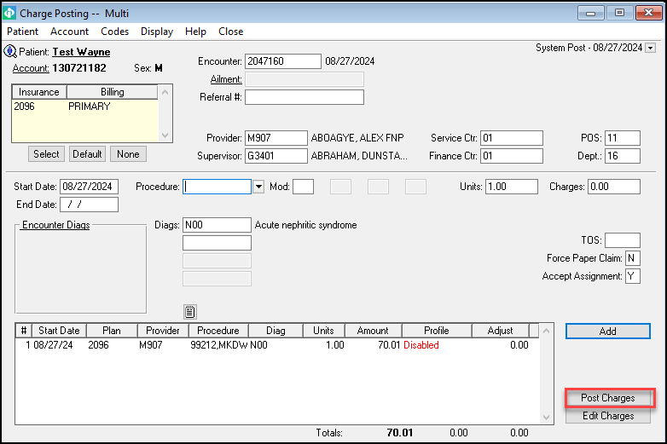

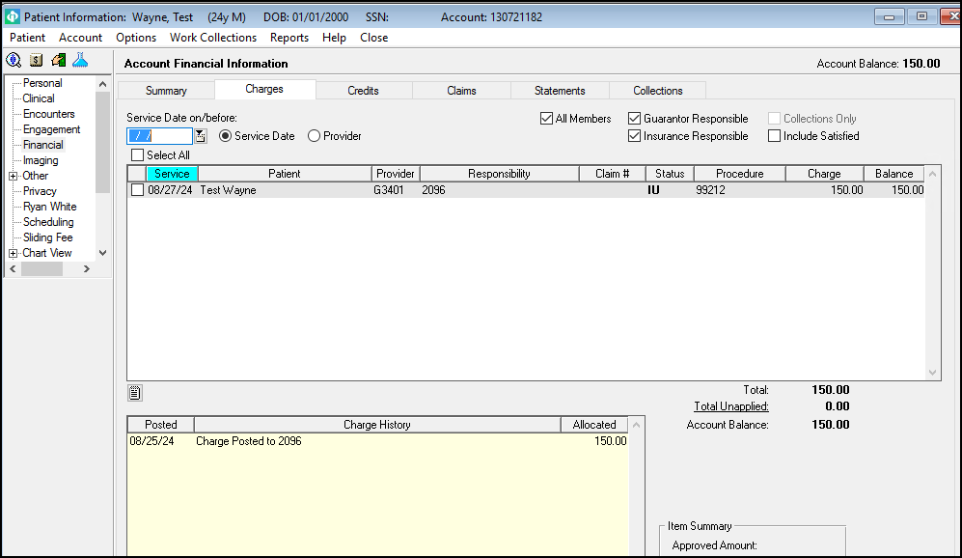

## **Admin Charge Posting**

Go to financial>>Charges>>Admin Charge Posting>>OK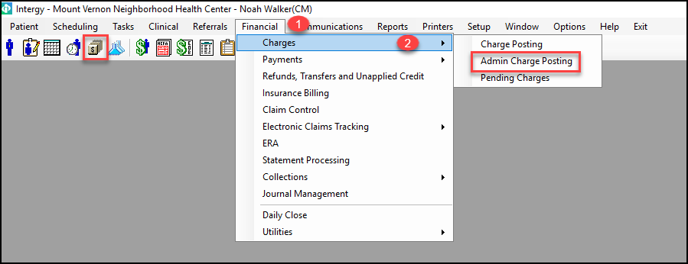  
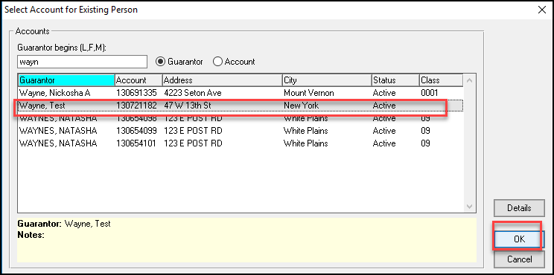

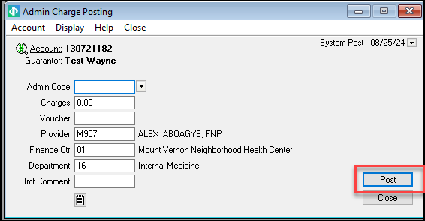

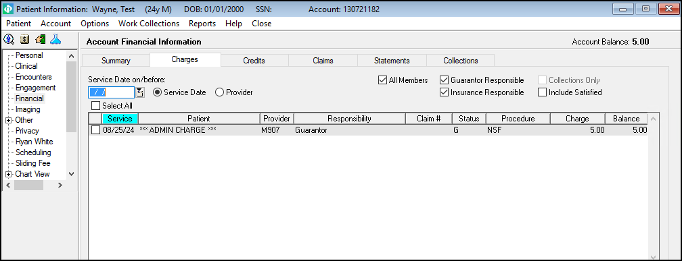

## **Pending Charges:**

Go to financial>>Charges>>Pending Charges>>Select Patient>>Post Pending Charge

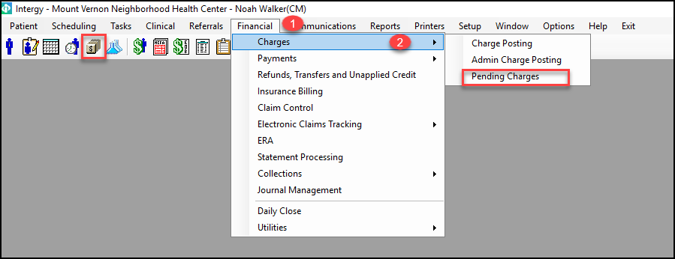

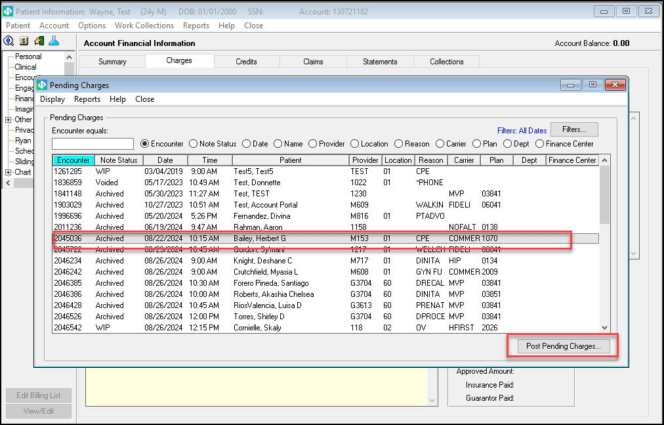

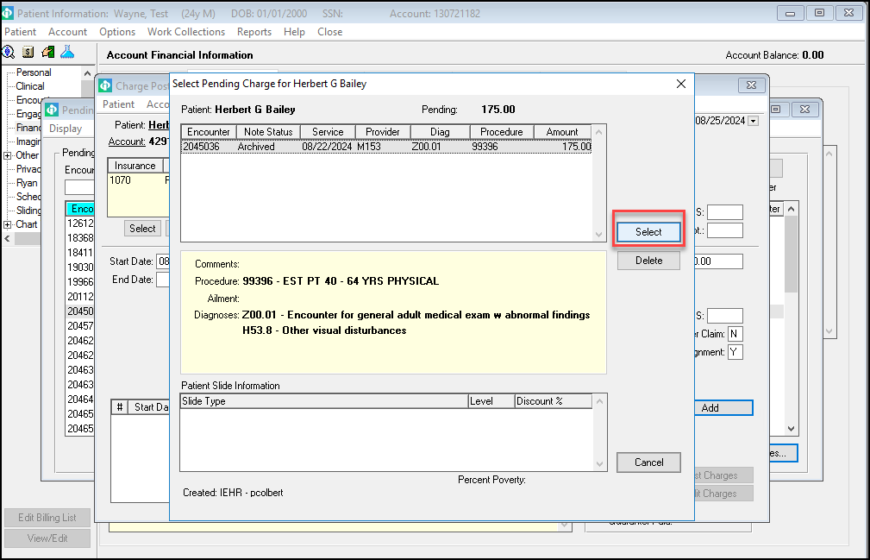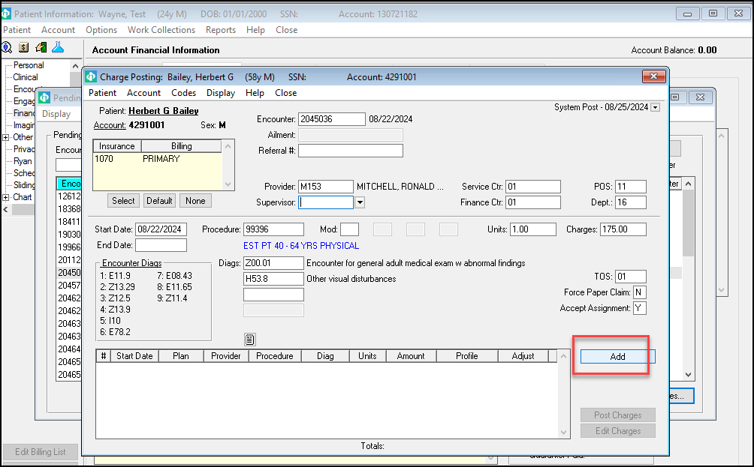

## **Plan Payment Posting**

Go to financial>>ERA>> Retrieve file >>yes (ERA have been downloaded into the system)

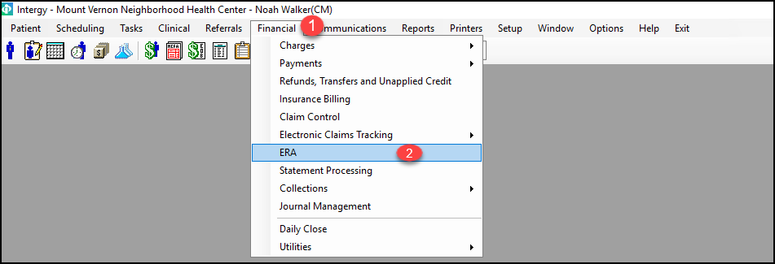  
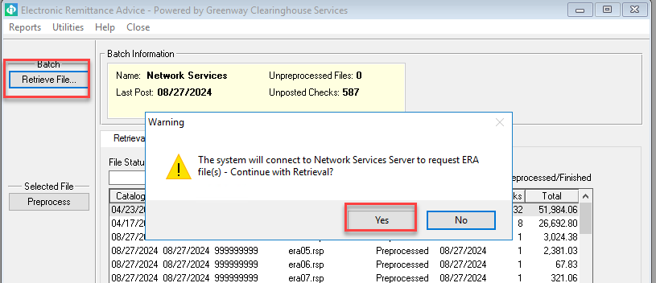

Go to Check Posting>>Select the check>> Run a Trail>>Then Run a Post

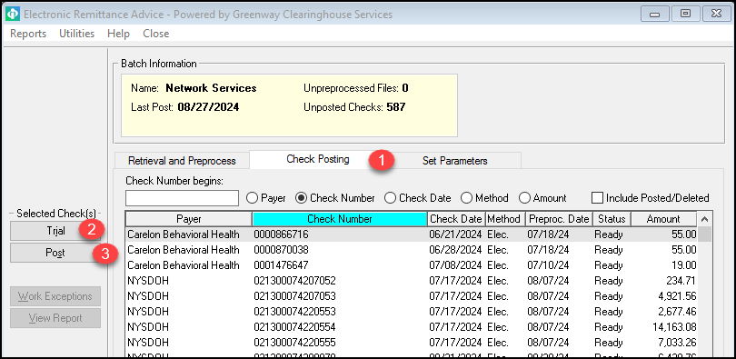

Manual EDI Import: Go to Utilities>>Import File>> Response File>> Save

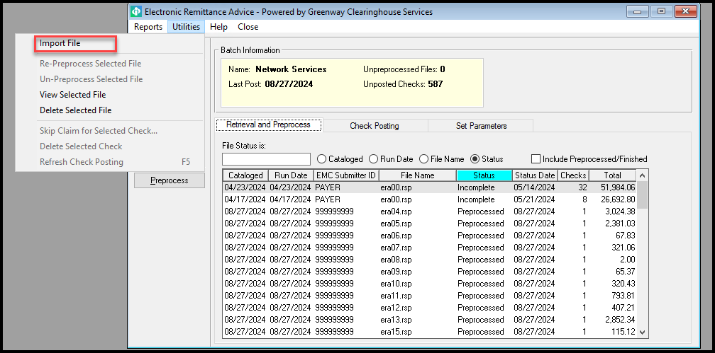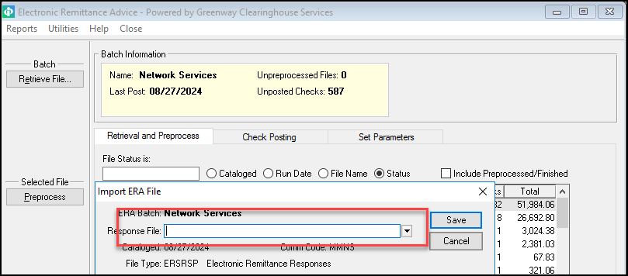

**Denials**   
Go to financial>>Claim Control

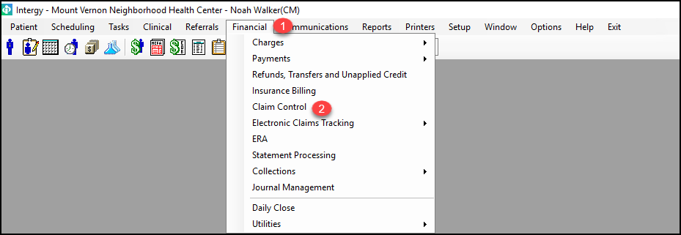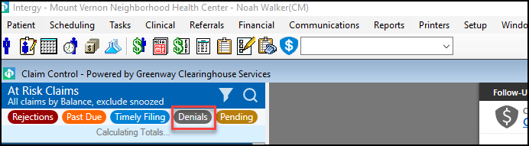

Insurance Rebill Utility

This feature can be utilized for Claim resubmission as highlighted Criteria in red in one click

Go to Financial>>Utilities>>Insurance Rebill Utility

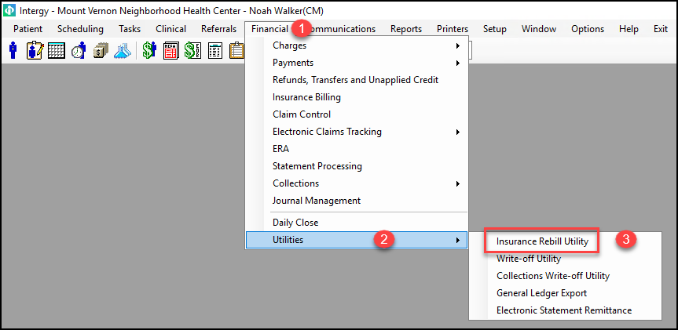 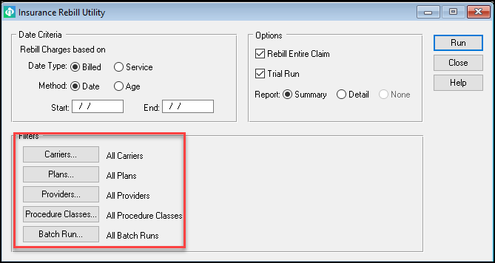

8. Write-off Utility

This feature can be utilized for claims adjustment based on multiple reasons.

Go to Financial>>Utilities>> Write-off Utility

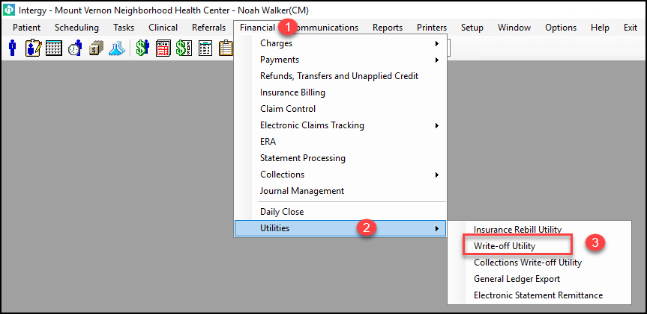

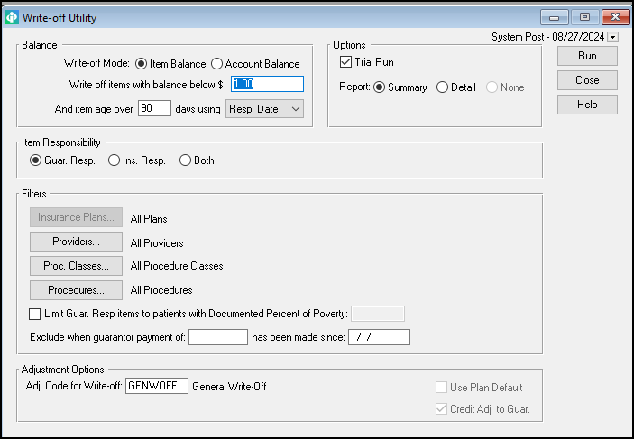

Collection Write-off Utility

This feature can be utilized for Patient Collection adjustment based on multiple reasons.

Go to Financial>>Utilities>> Collection Write-off Utility

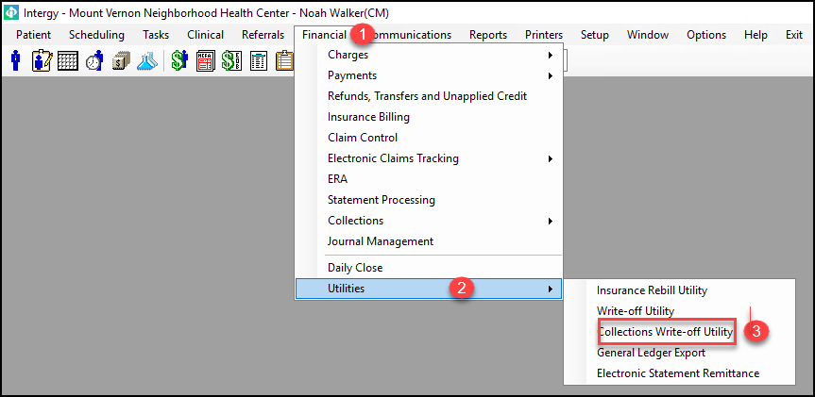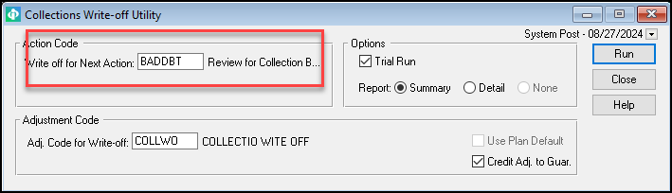

## **Patient Payment Posting**

Go to Financial>>Utilities >>Payments>>Account

